1) Create s3 bucket and upload some objects to s3.

**Creating an s3 bucket:**

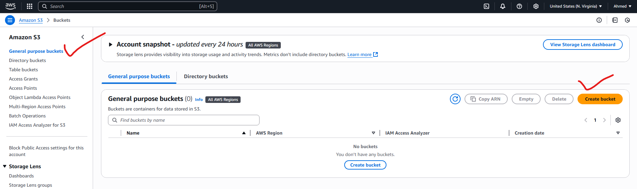

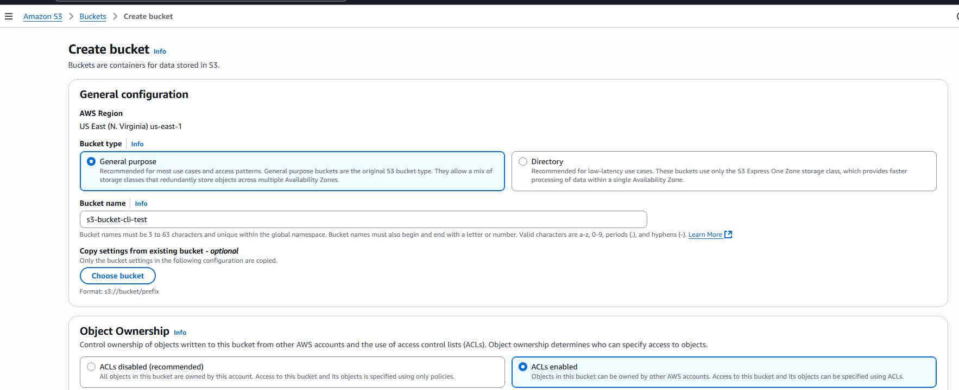

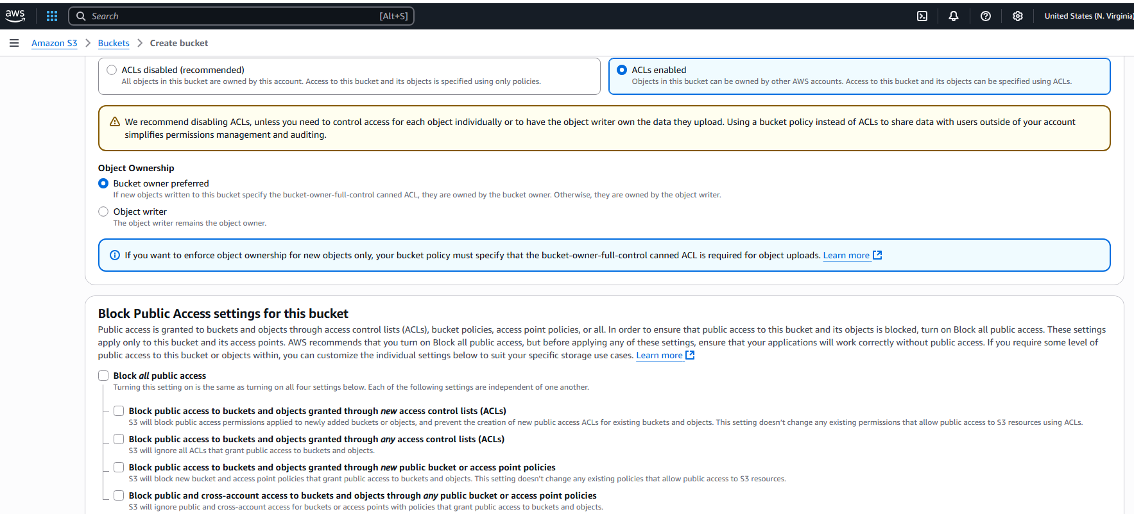

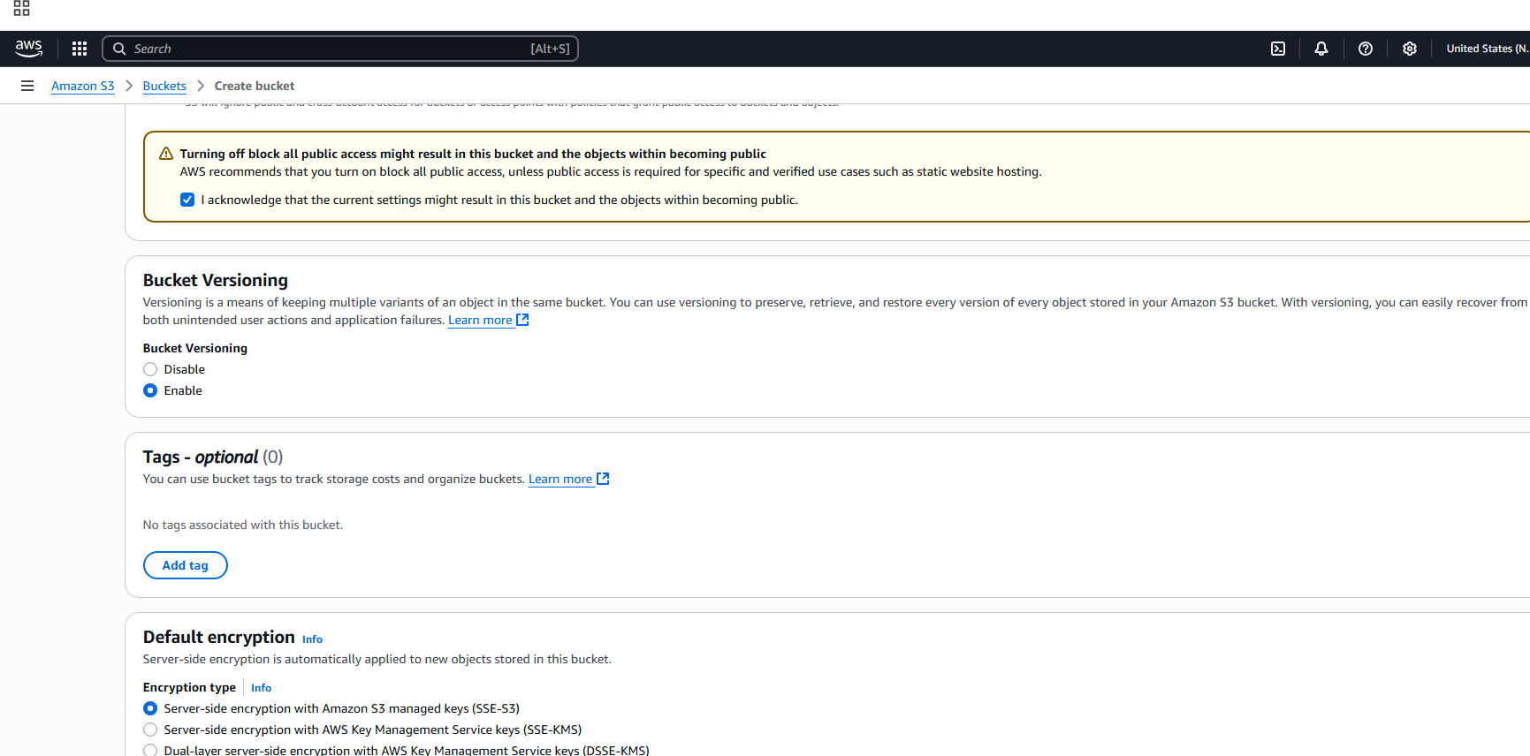

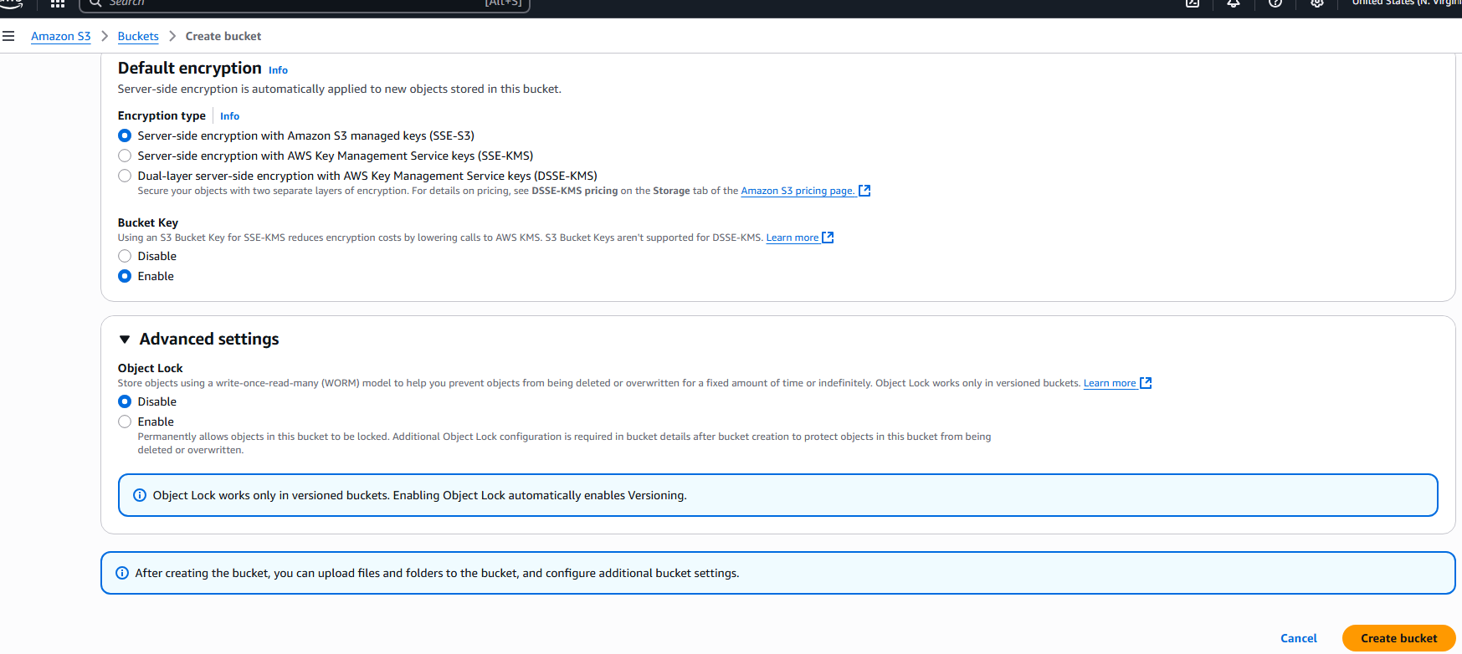

S3 bucket created:

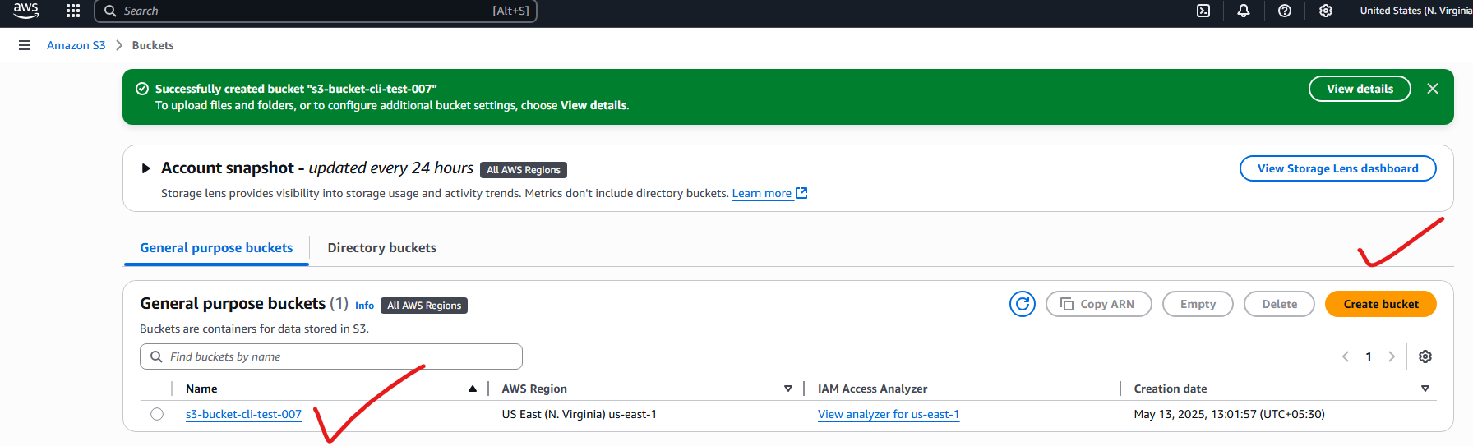

**Uploading objects to s3:**

Click on bucket:

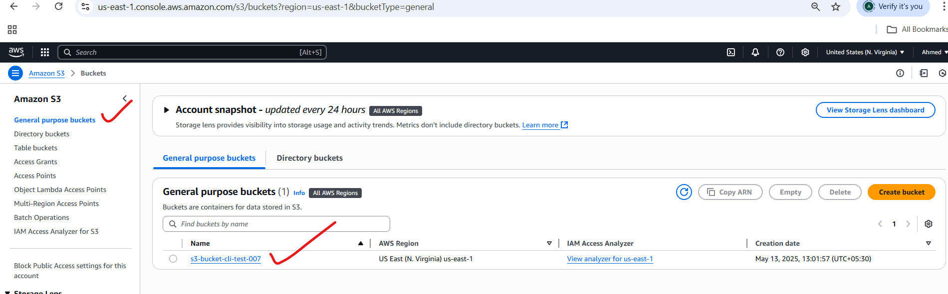

Clicke on upload:

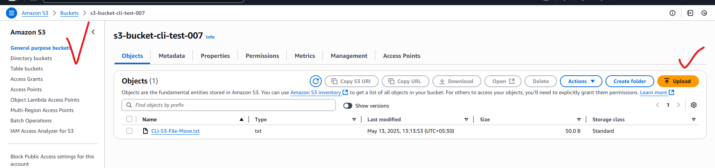

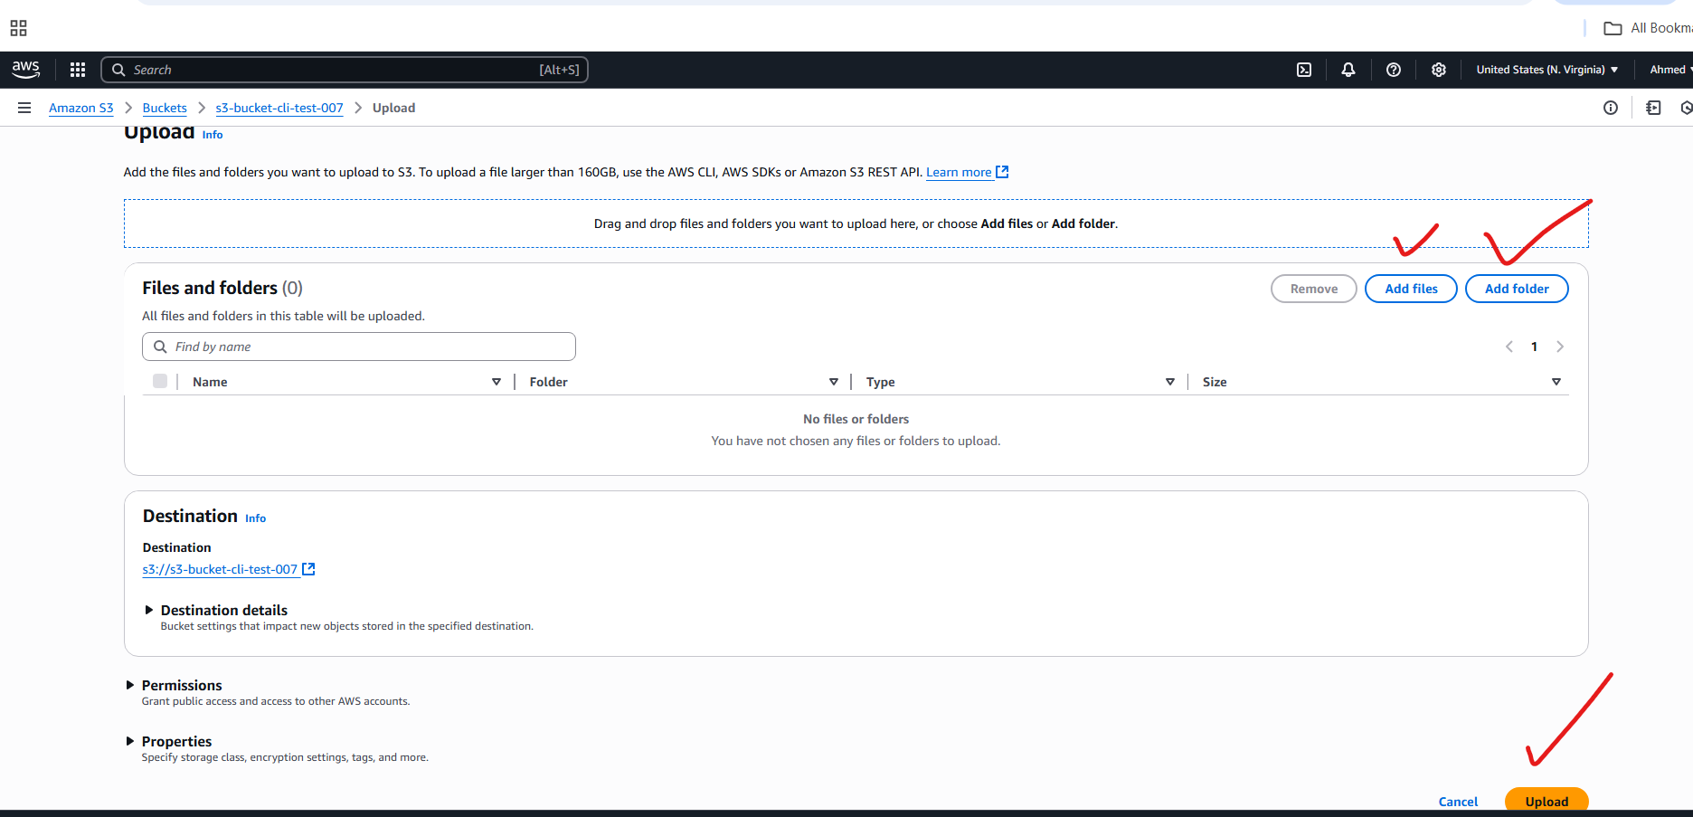

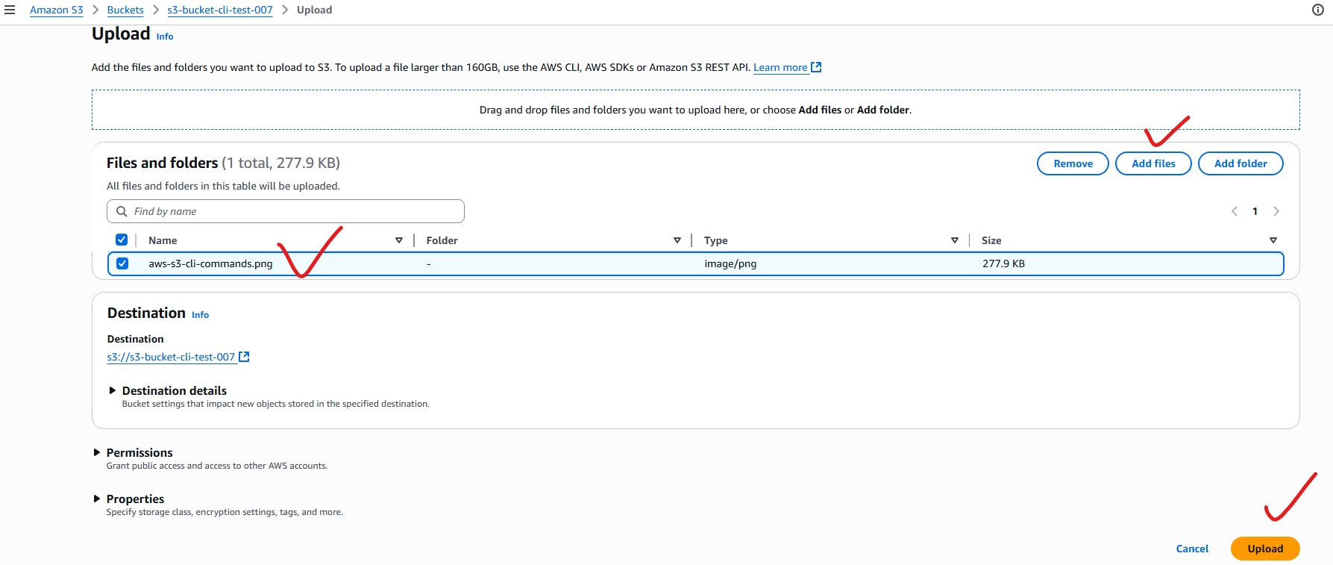

Object added successfully:

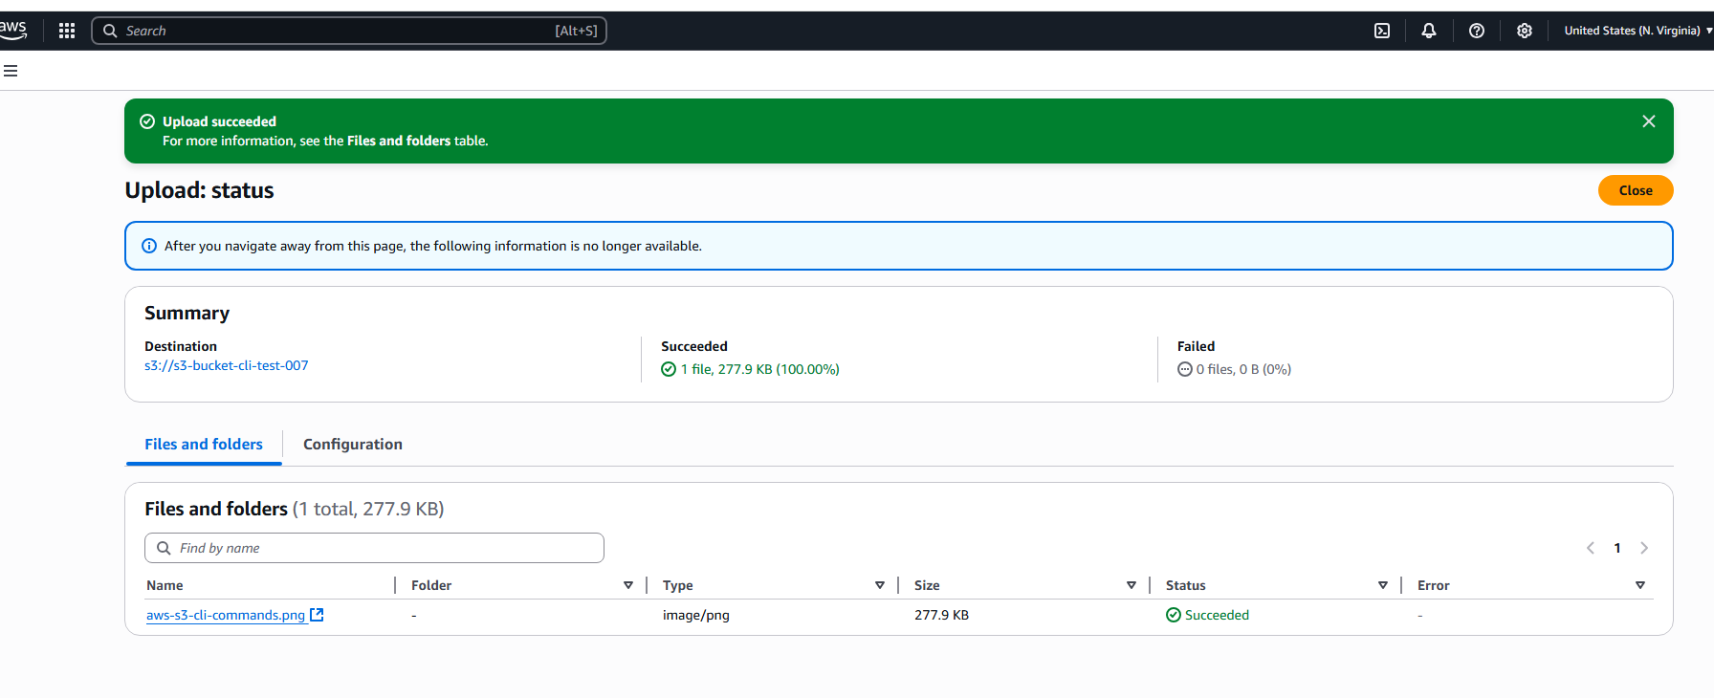

Note: to view the object using object url, first we make that object public.

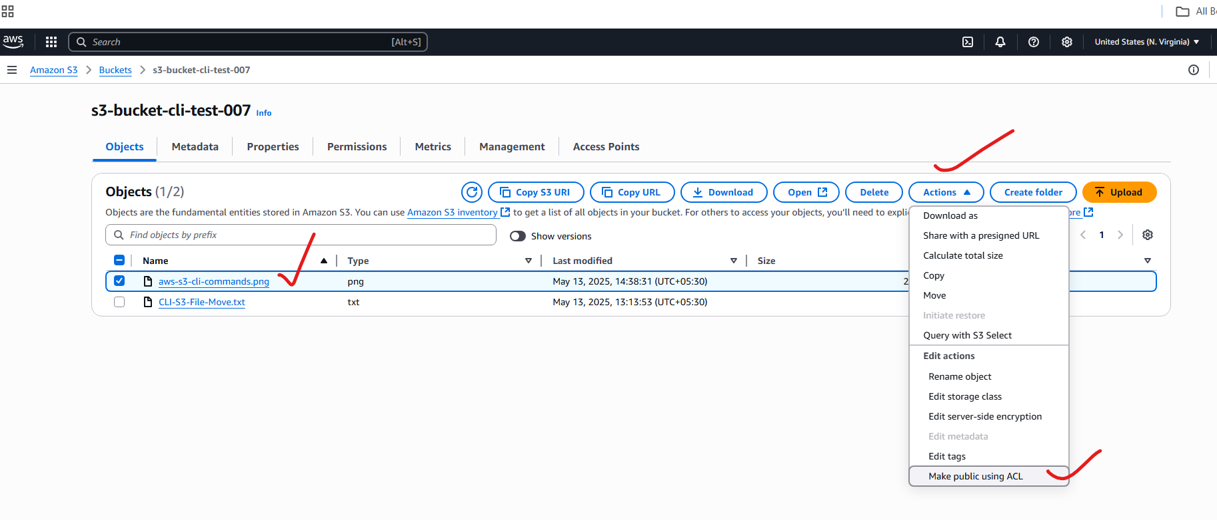

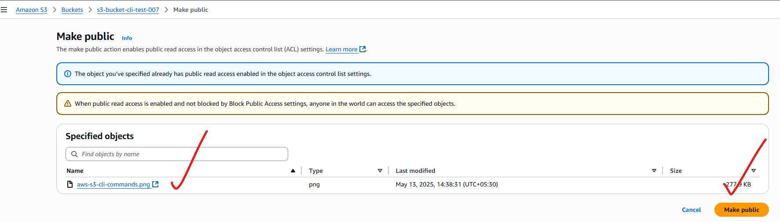

Viewing the object through bucket url:

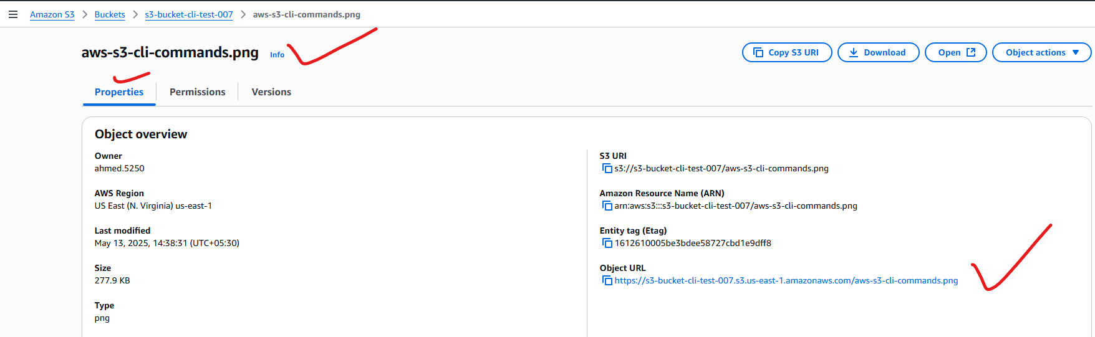

Copy the url and paste in browser:

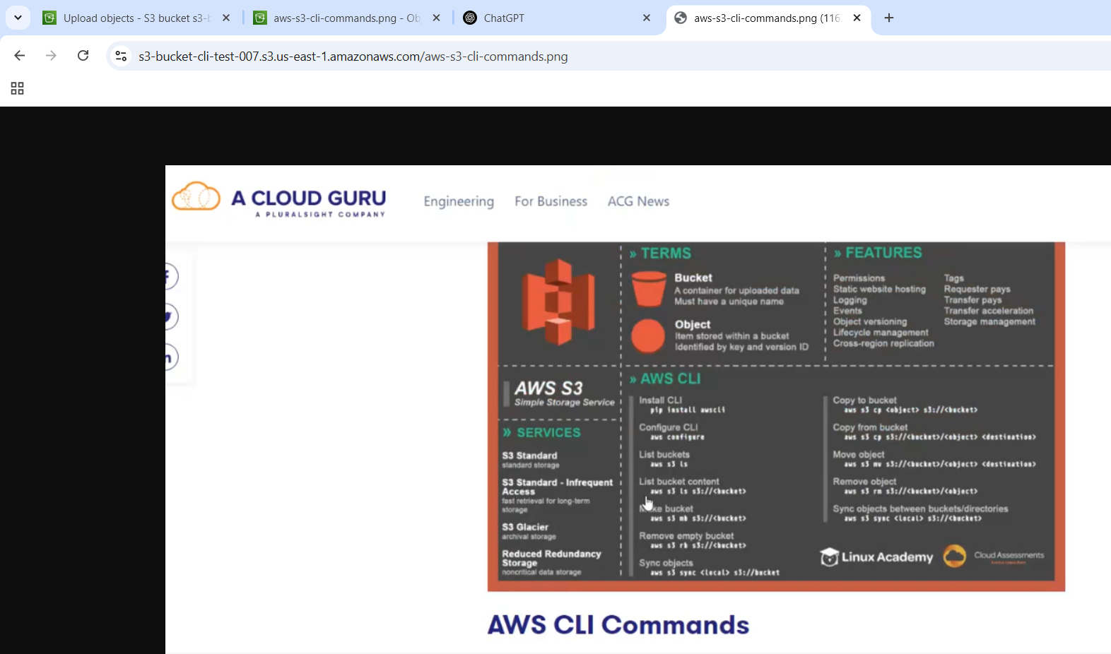

**2) Deploy static website in s3 bucket.**

I created the bucket with the name**: my-static-website-upload-s3**

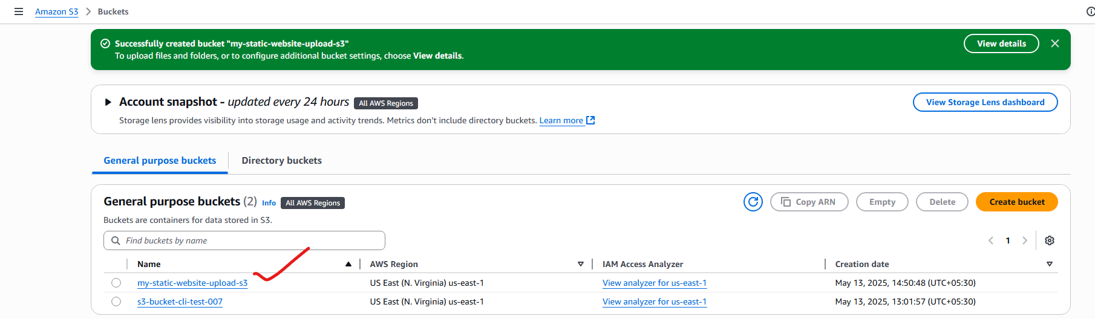

Uploading the sample static website to s3-bucket:

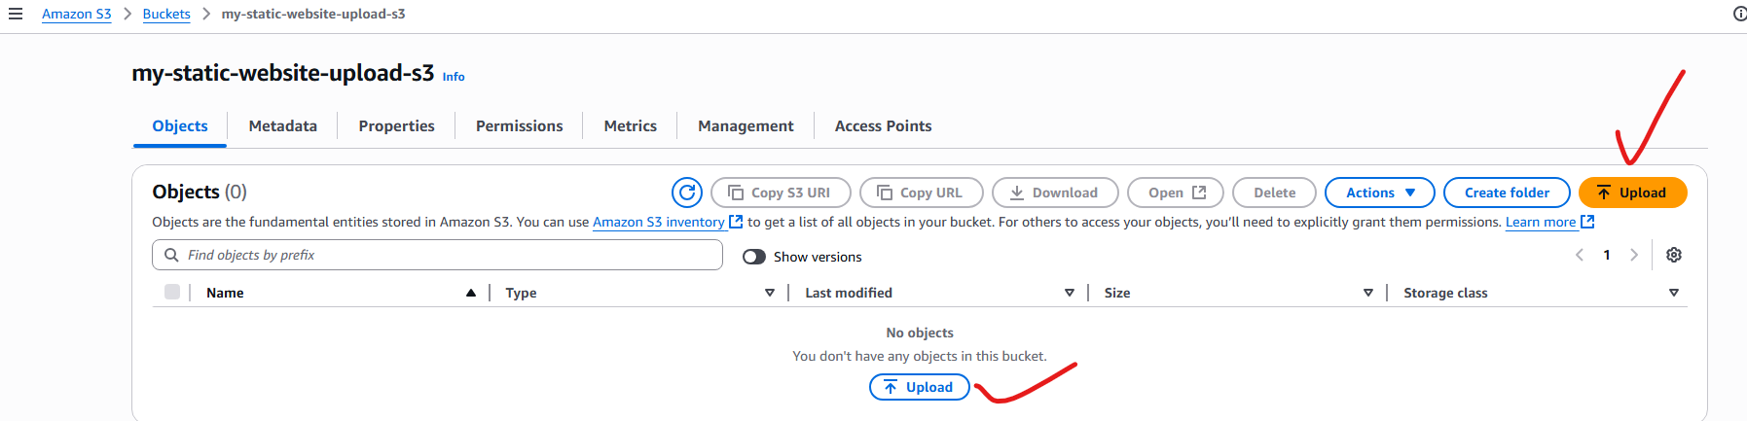

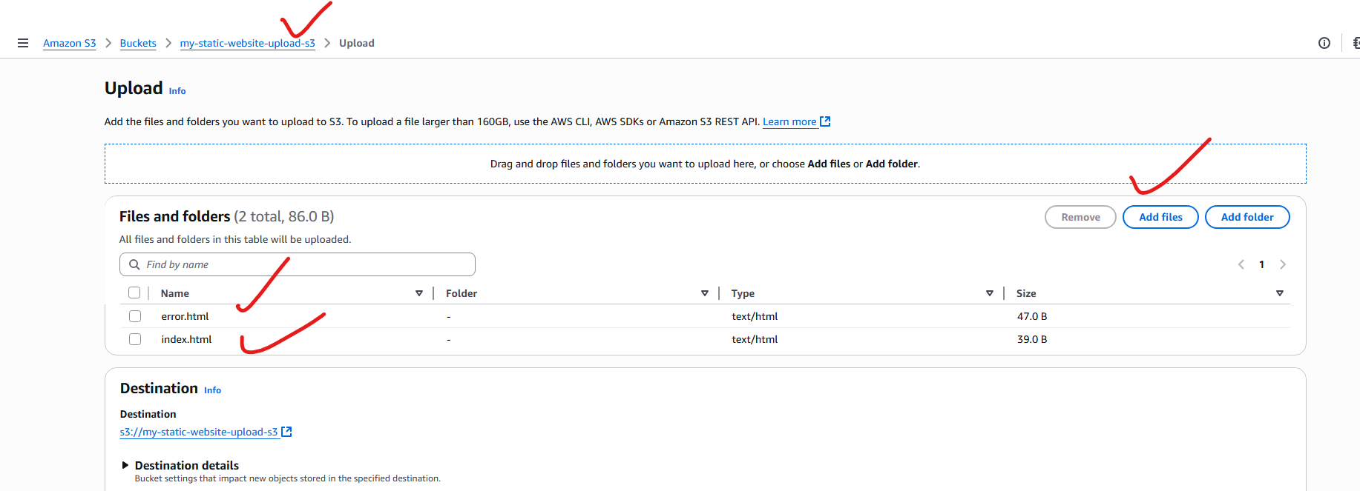

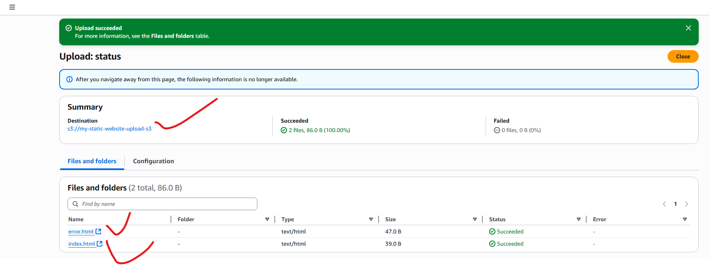

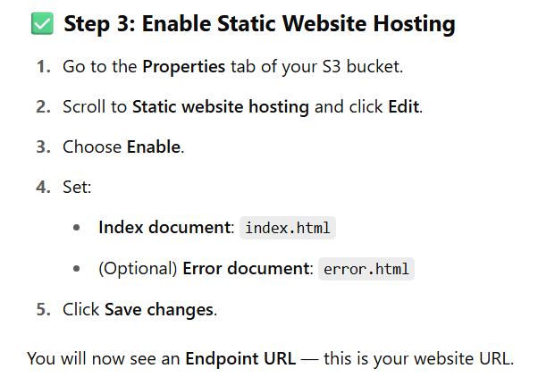

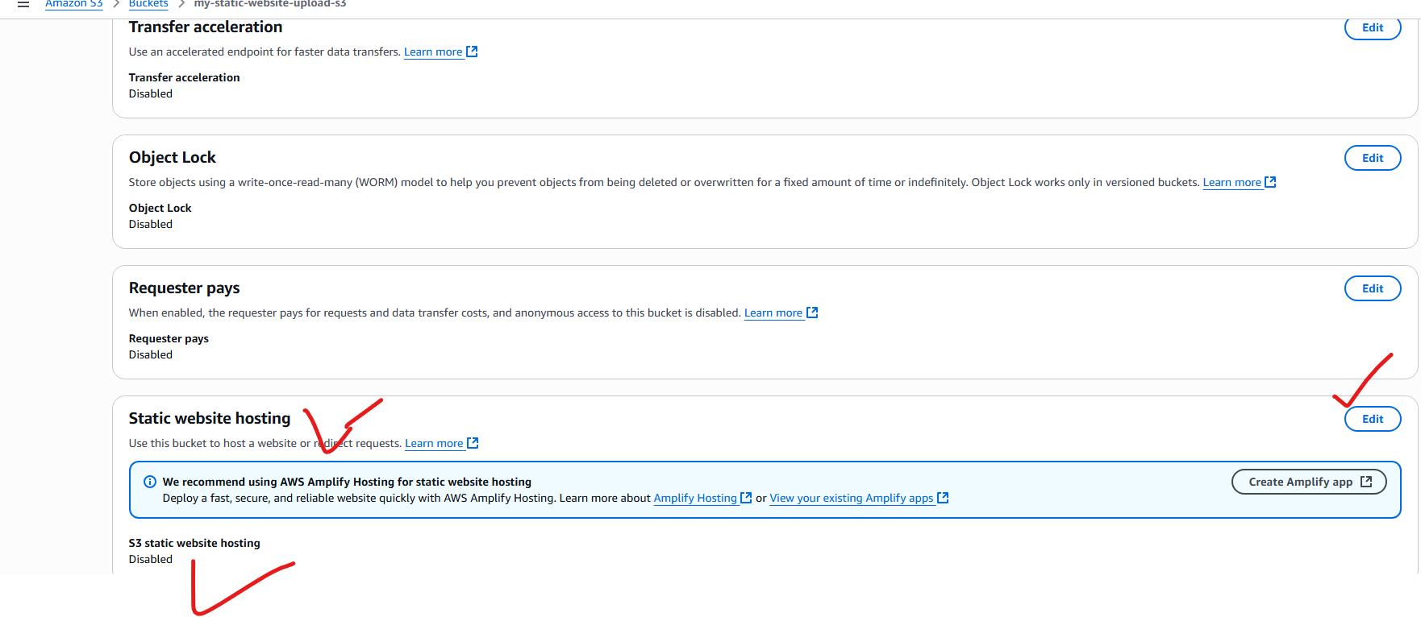

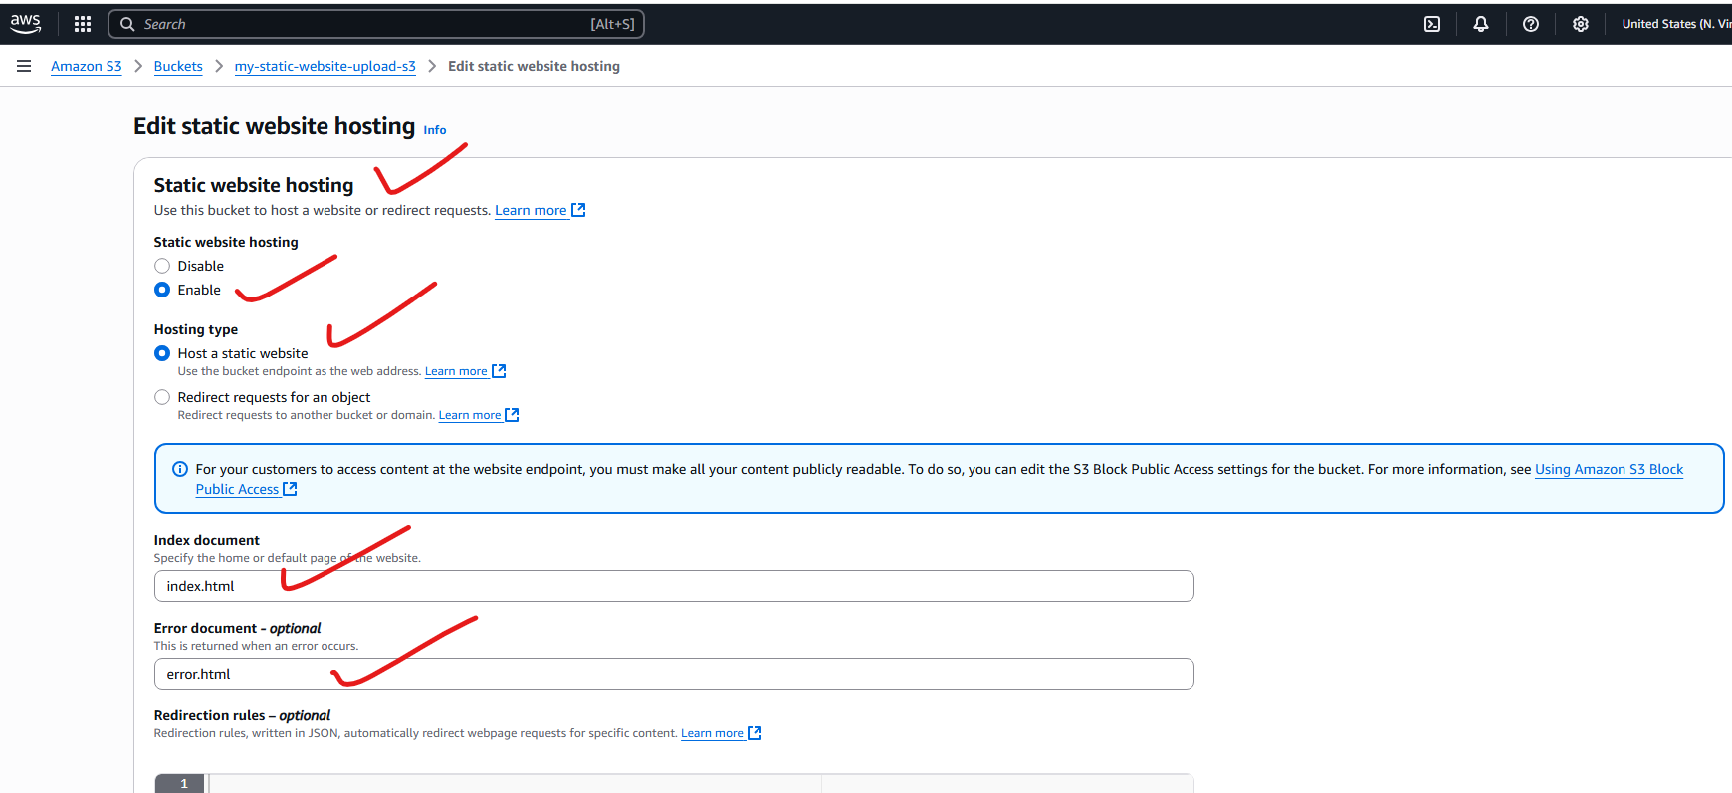

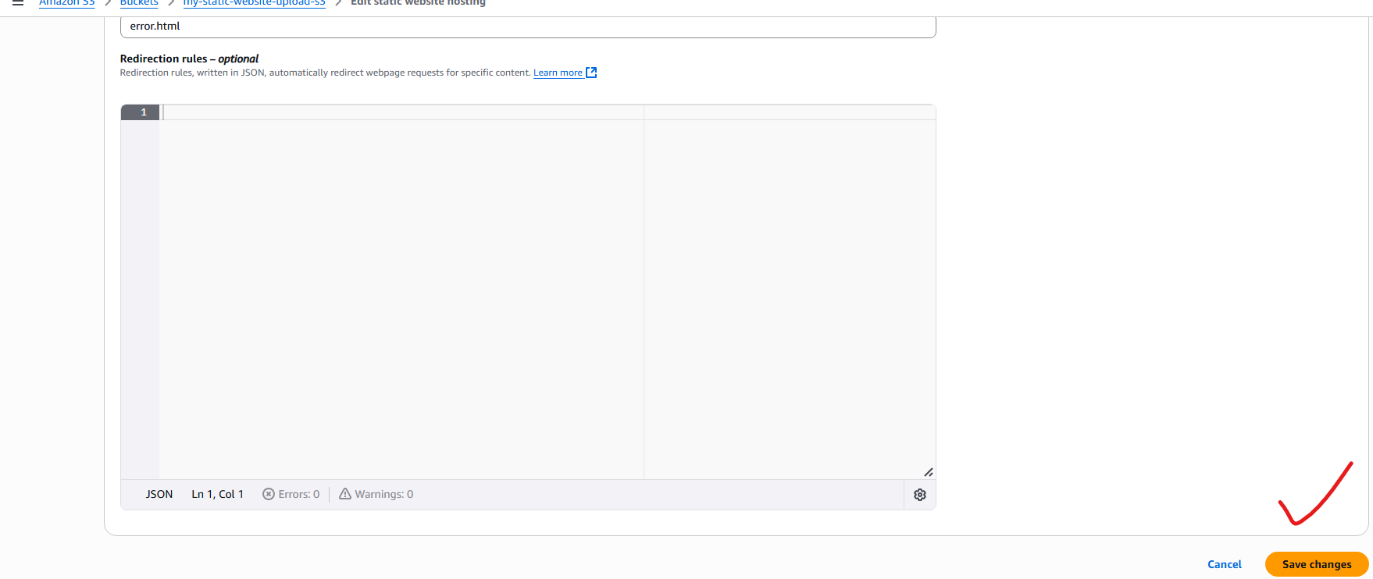

**Now you will get a bucket url:**

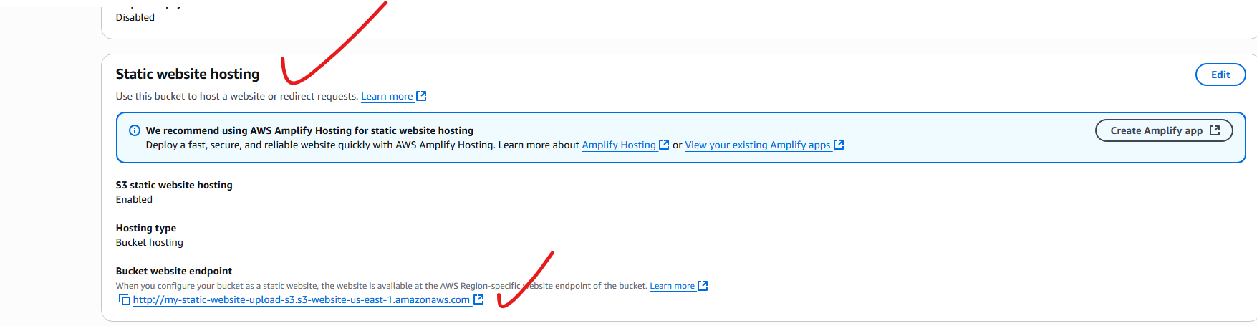

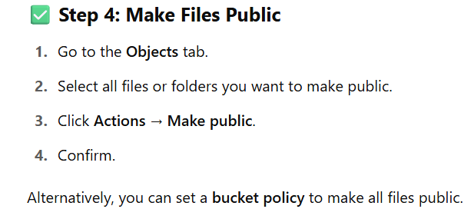



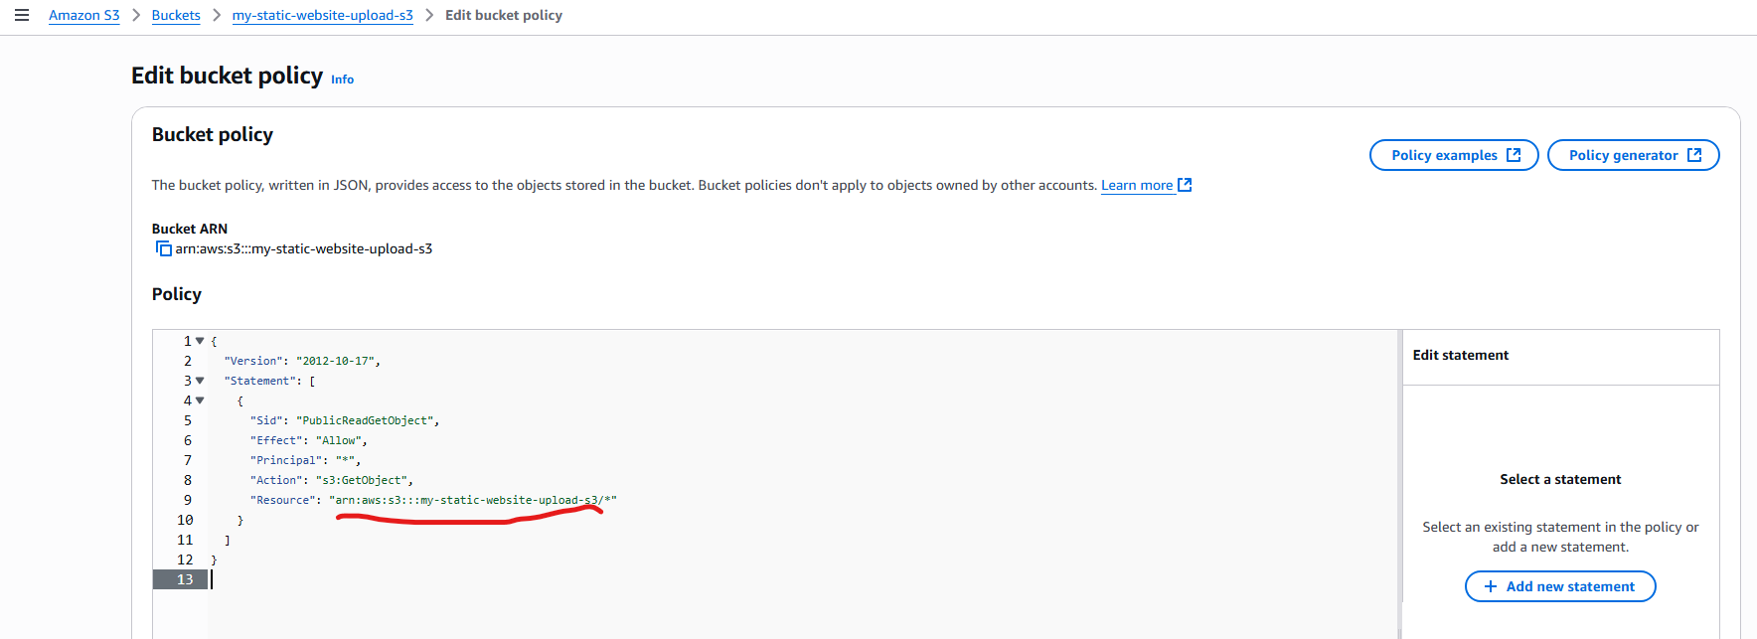

**Copy this bucket level url and paste in browser:**

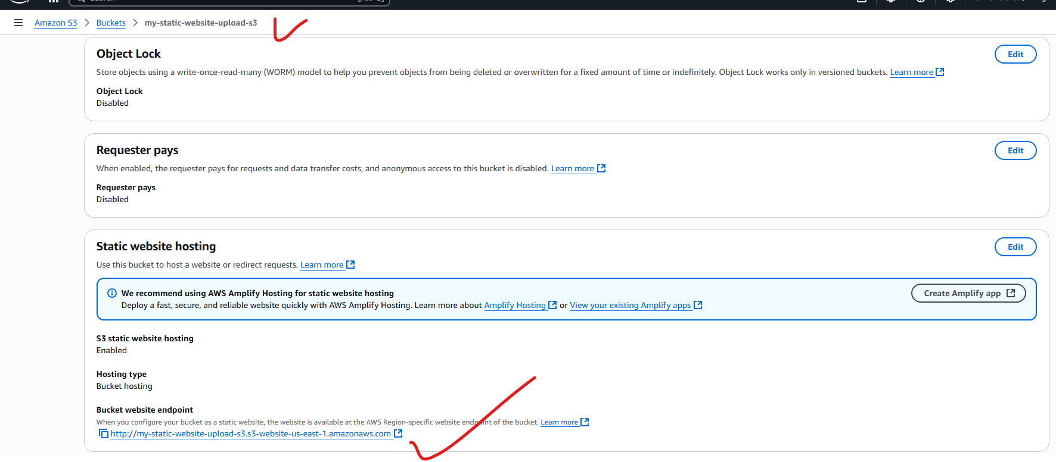

**Getting static website home page:**

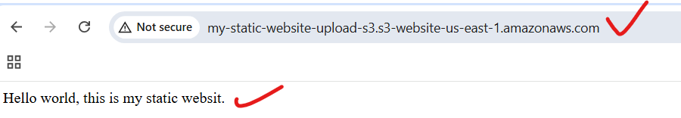

**If the static website is in maintenance mode:**

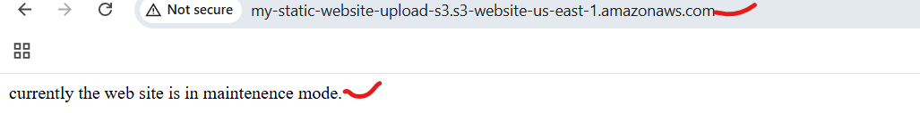

**3) Enable cross region replication on s3 buckets:**

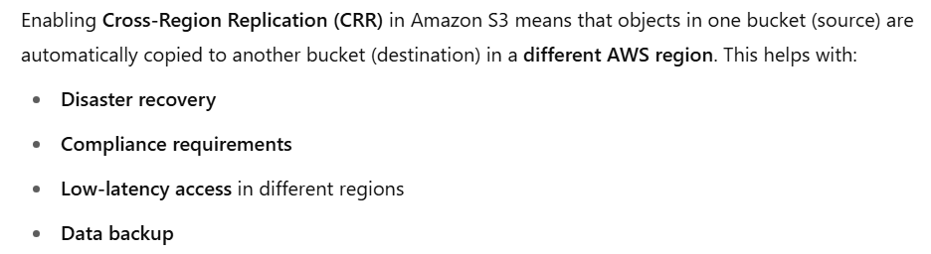

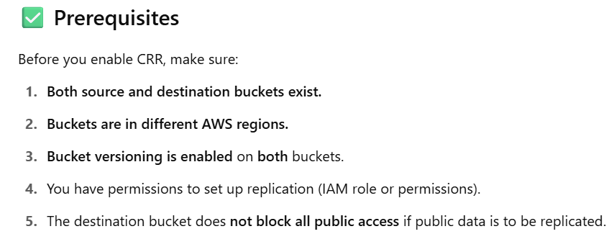



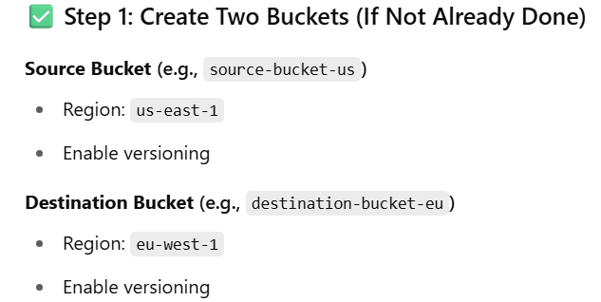

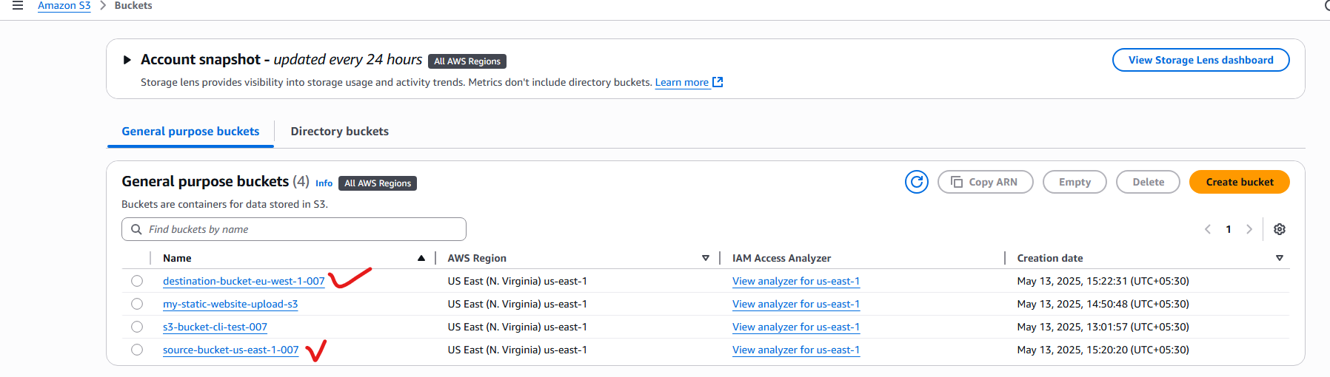

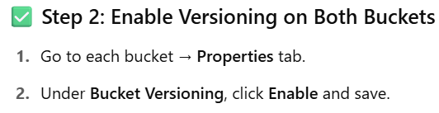

Note: Done the above setting already.

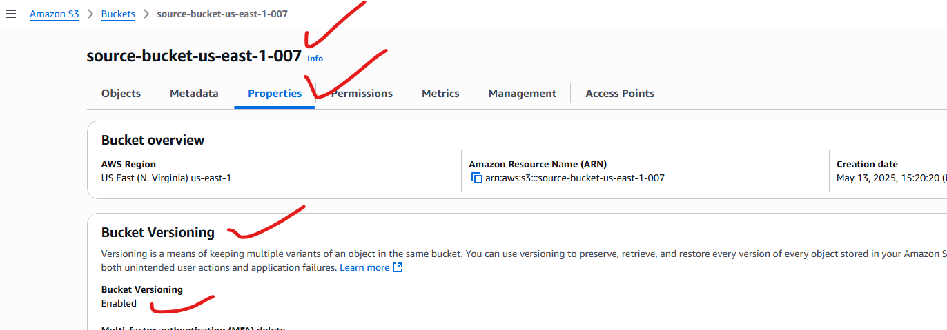

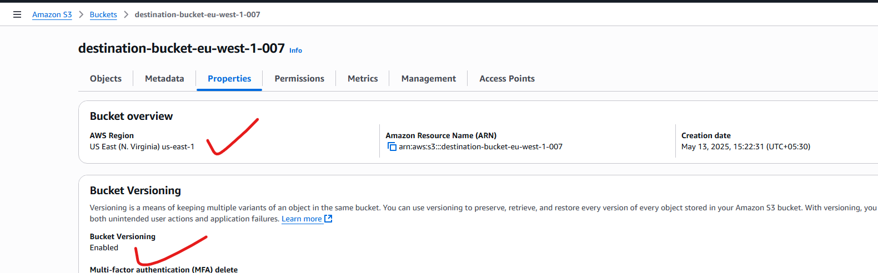

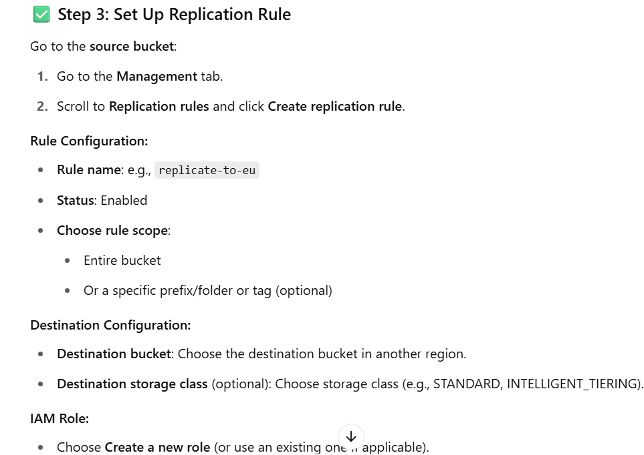

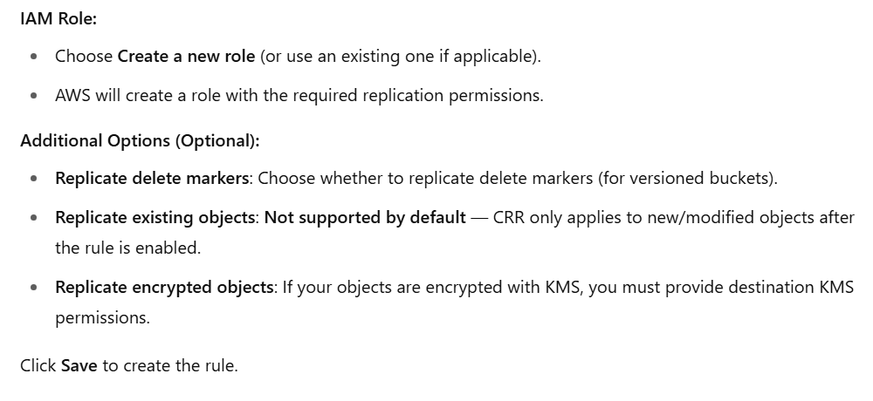

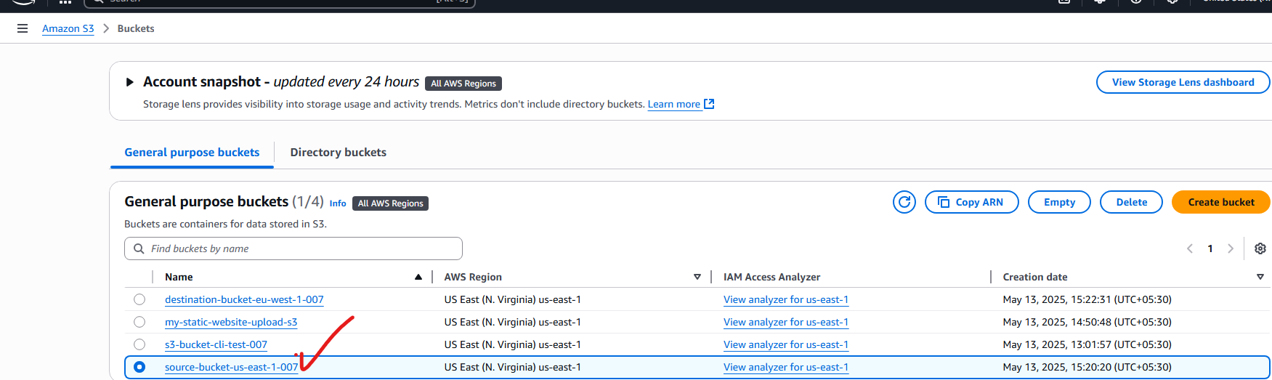

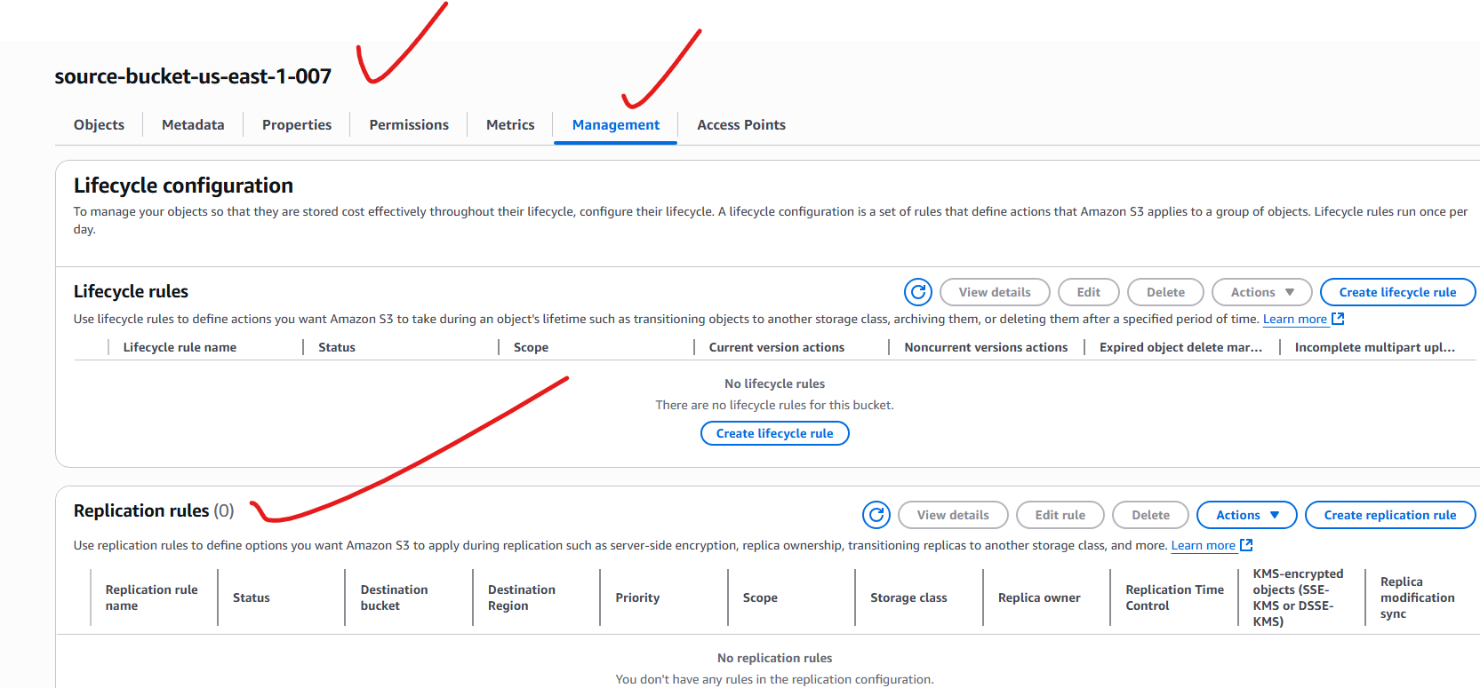

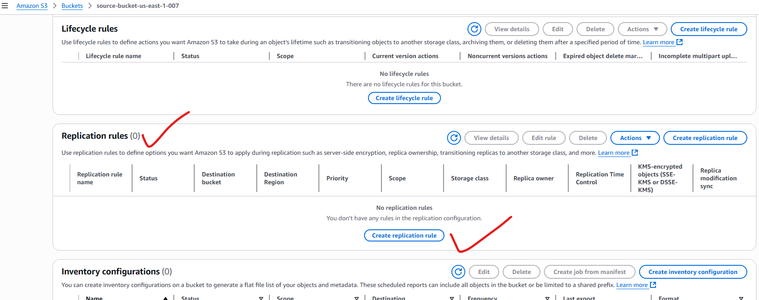

**replicate-to-eu-west-1 (ireland):**

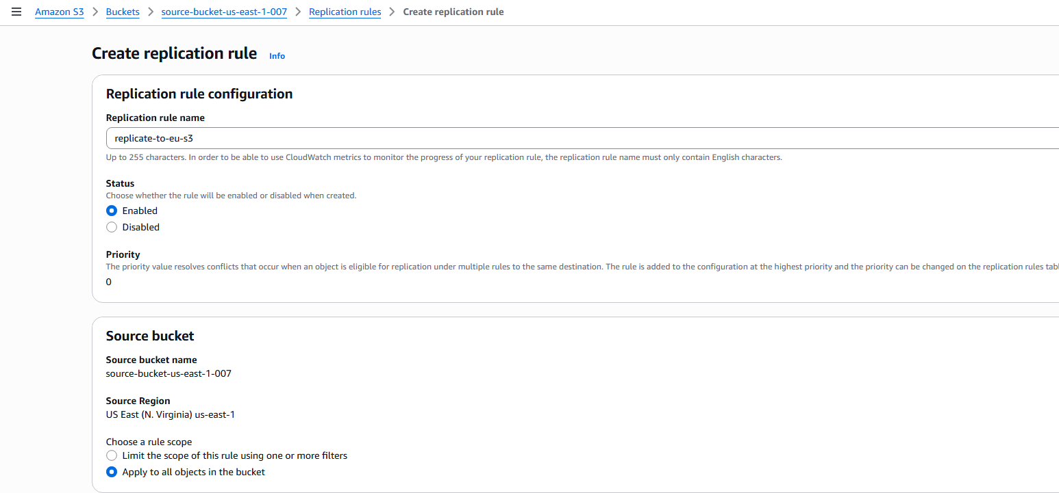

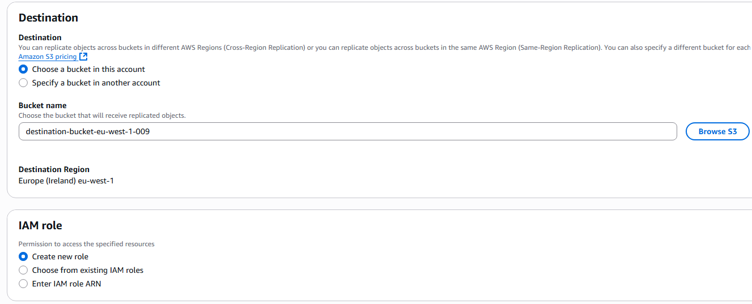

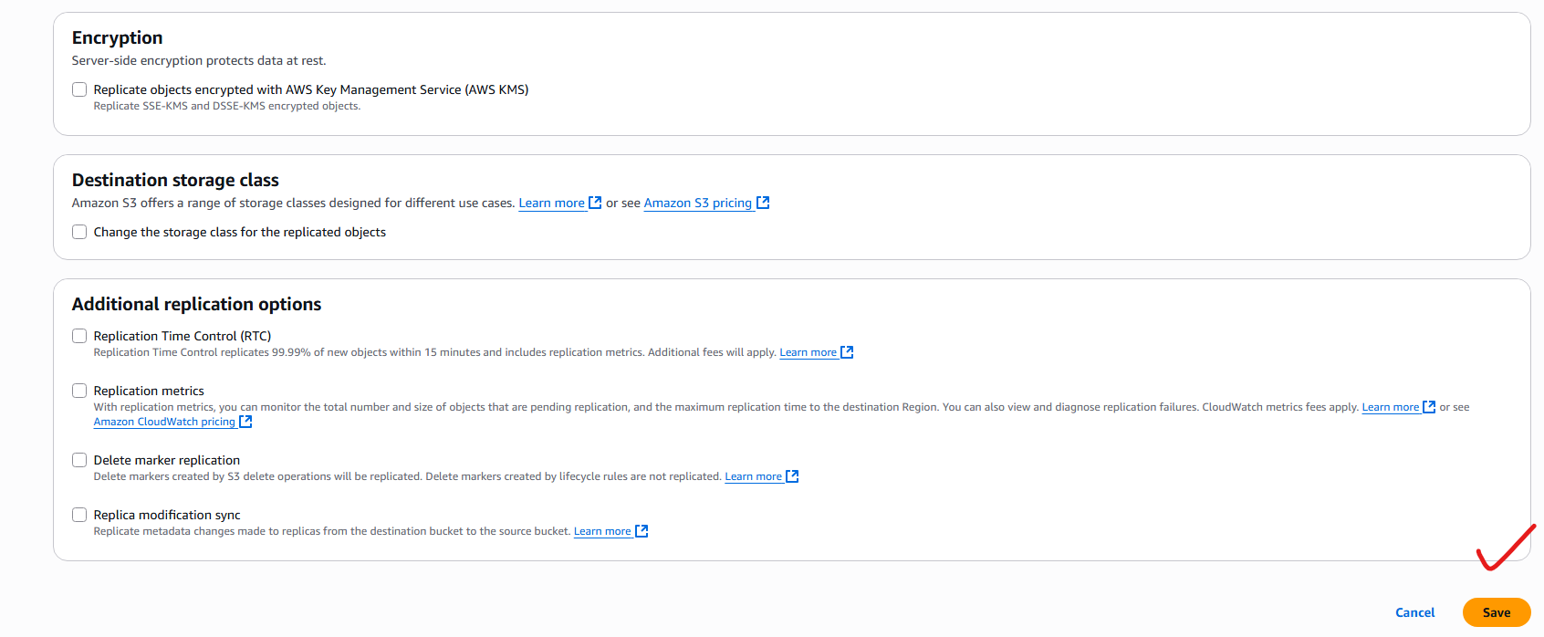

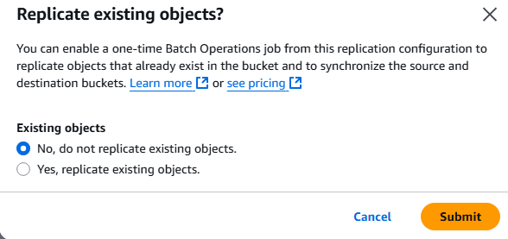

**Uploaded an object (error.html):**

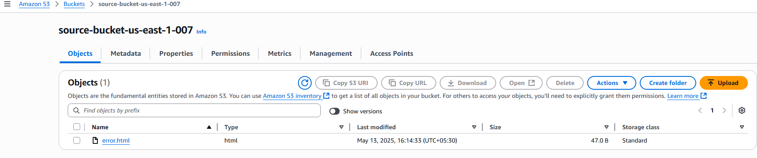

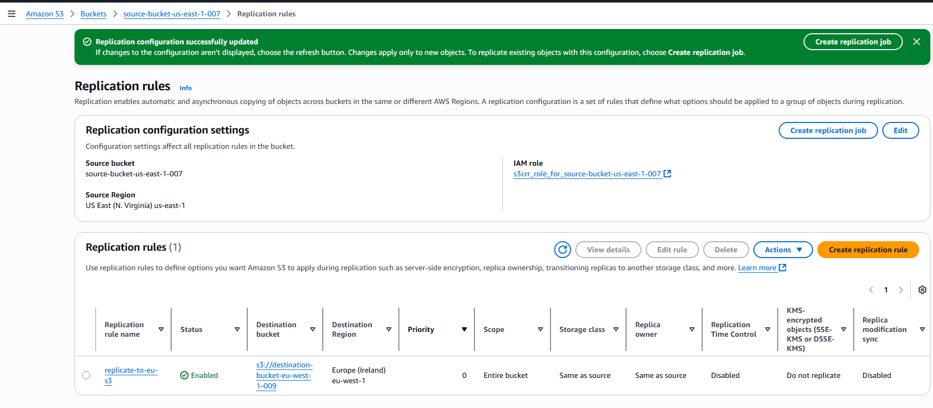

**Redirected the object to destination bucket:**

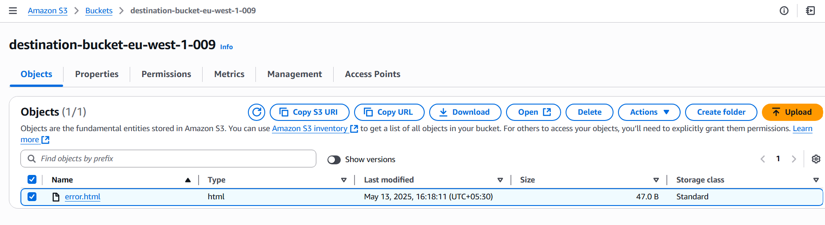

**Adding one more object (index.html)**

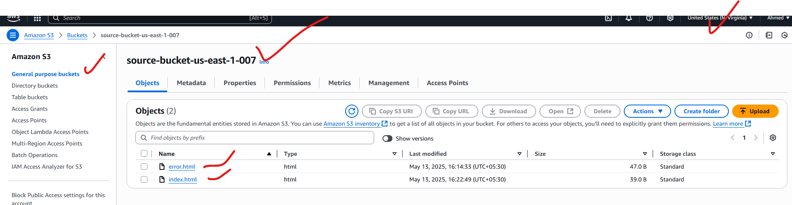

**Redirecting to destination s3-bucket (index.html)**

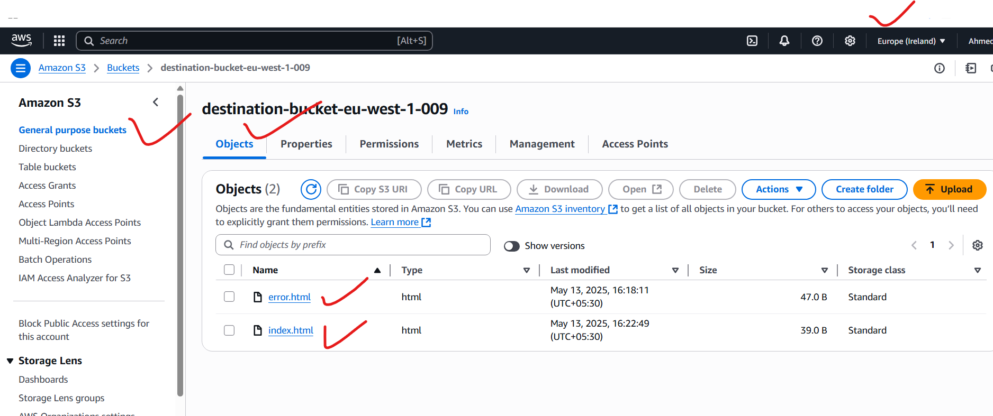

**4) Configure bucket policy, only Admin user can see the objects of s3 bucket:**

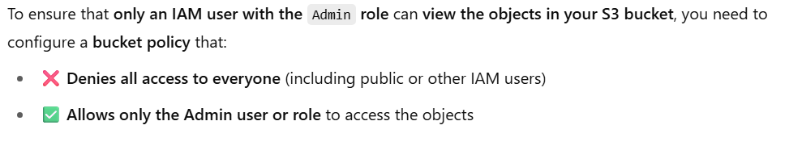

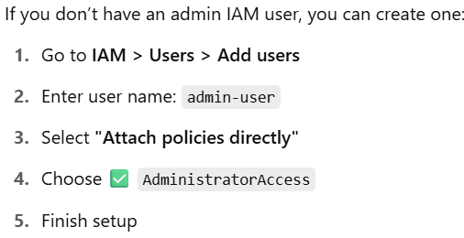

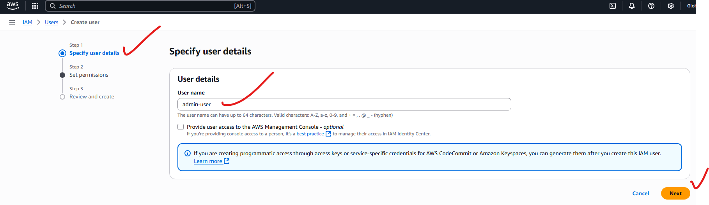

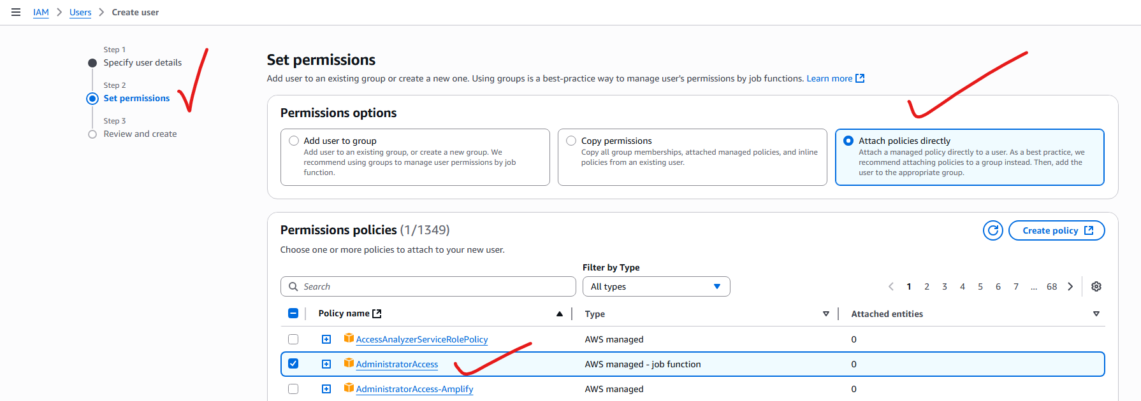

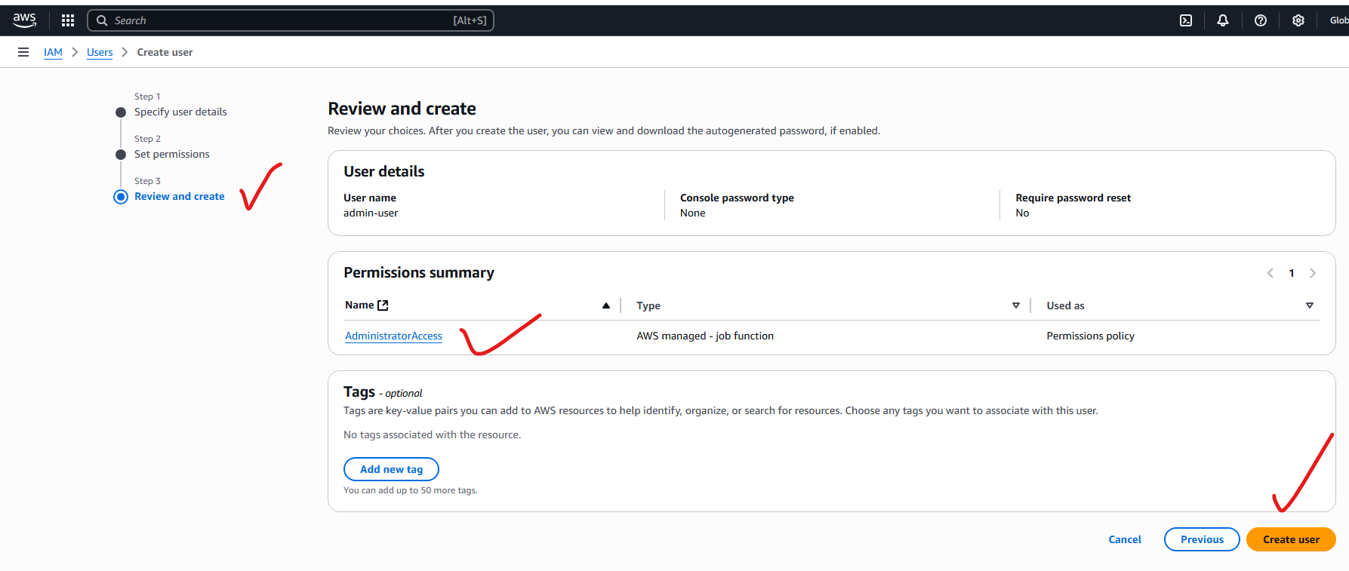

**If we created a normal-user and login to AWS account with IAM-login-url, and entering the details, after login, goto s3 service and try to see the objects in the s3, then it is showing the “access denied”**

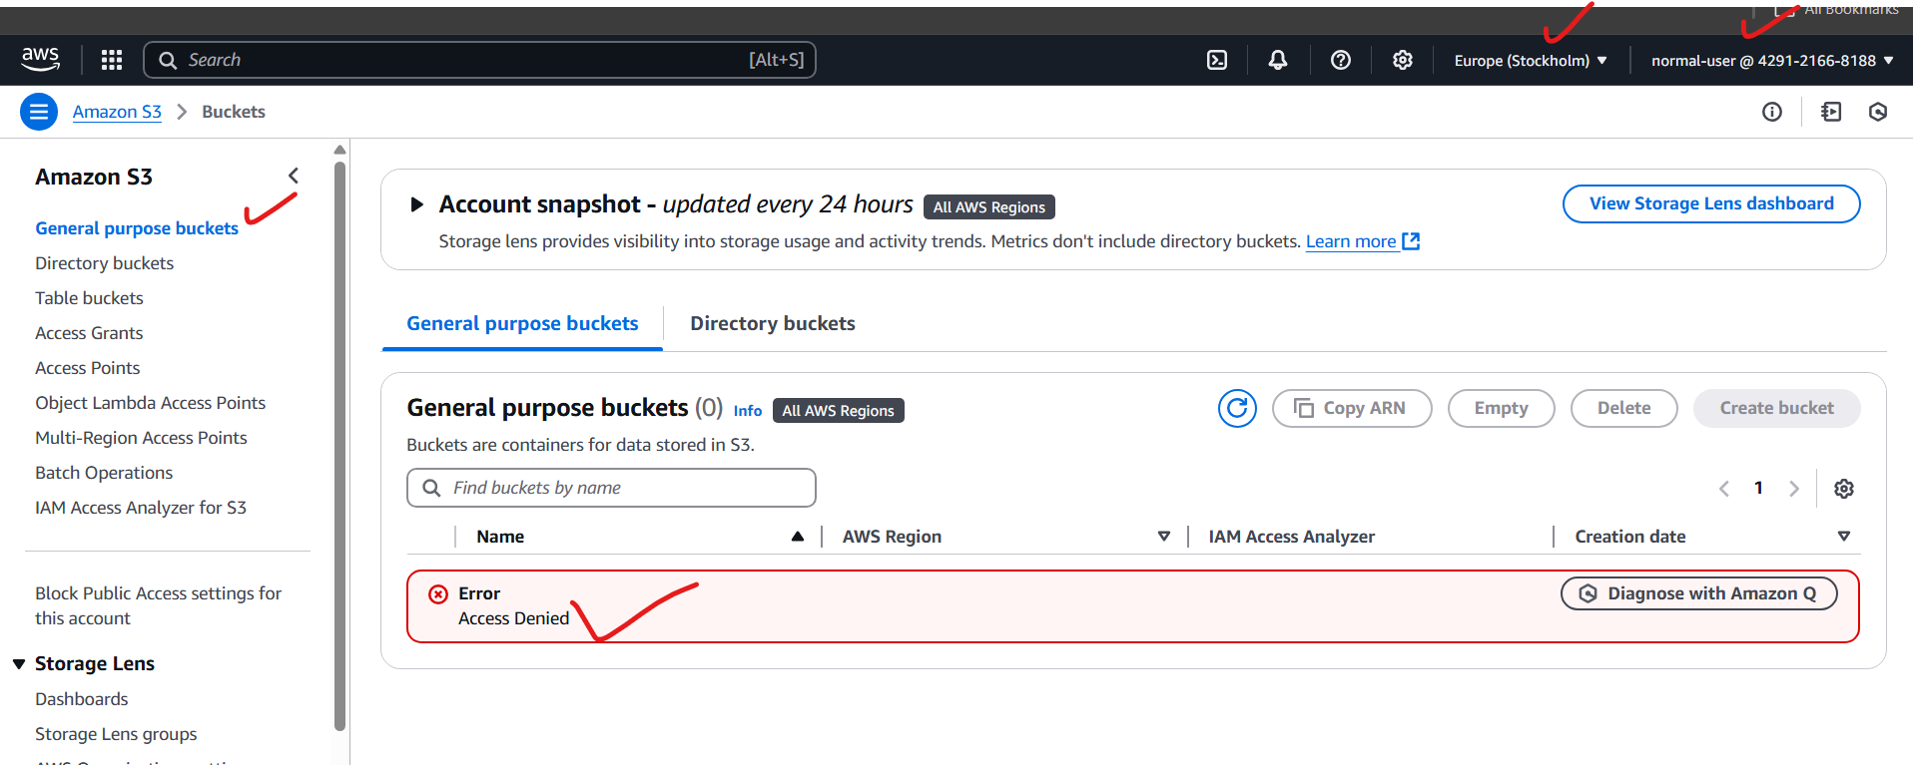

**Again if you login the AWS console with admin-user or root-user it will show all the s3 bucket objects.**

**I created a user called admin-user, and login with this user, having “Administrative Full Access”**

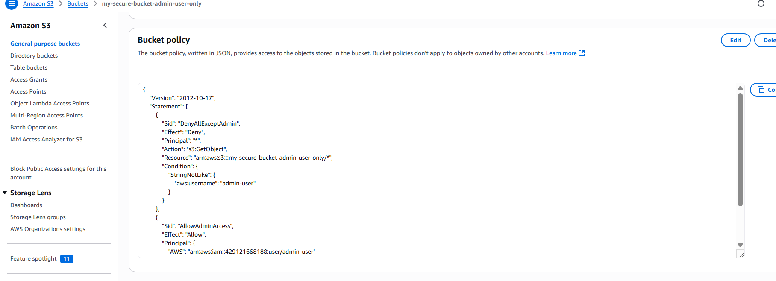

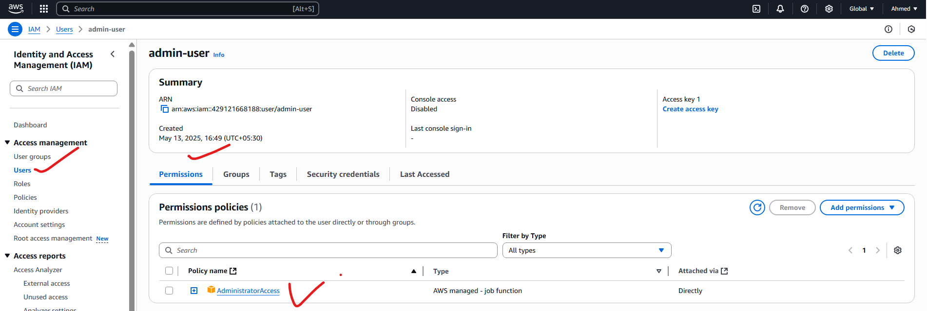

**Login with this account:**



**Enable console access in “security credentials” and we get the details or link here to login-url and password and username:**

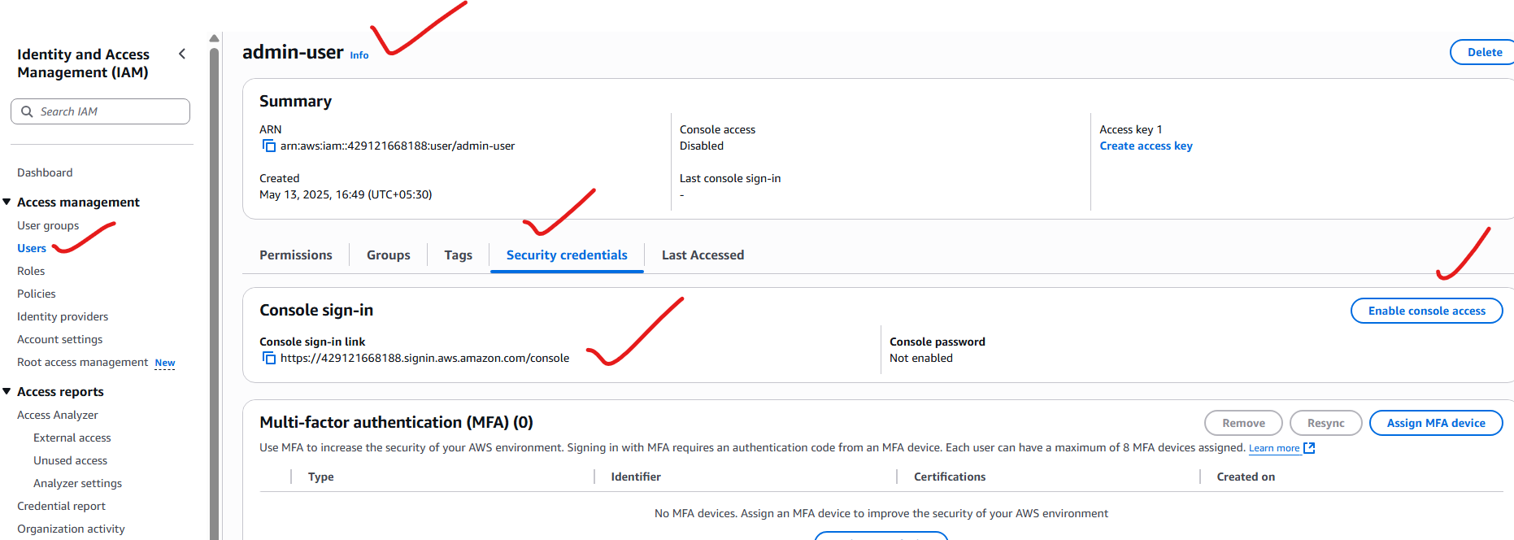

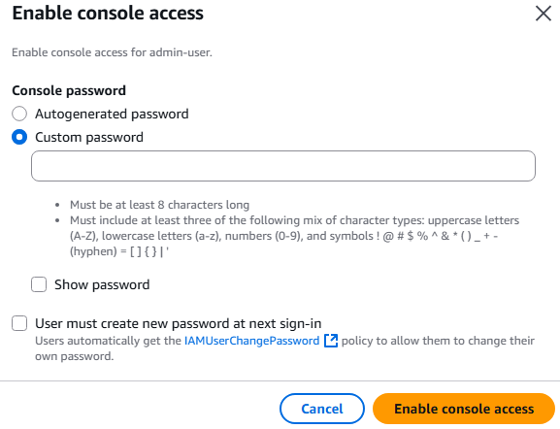

**Here iam getting the s3 objects:**

**Login in incognito with IAM admin-user(which I have created with “AdministratorAccess” permissions) and password:**

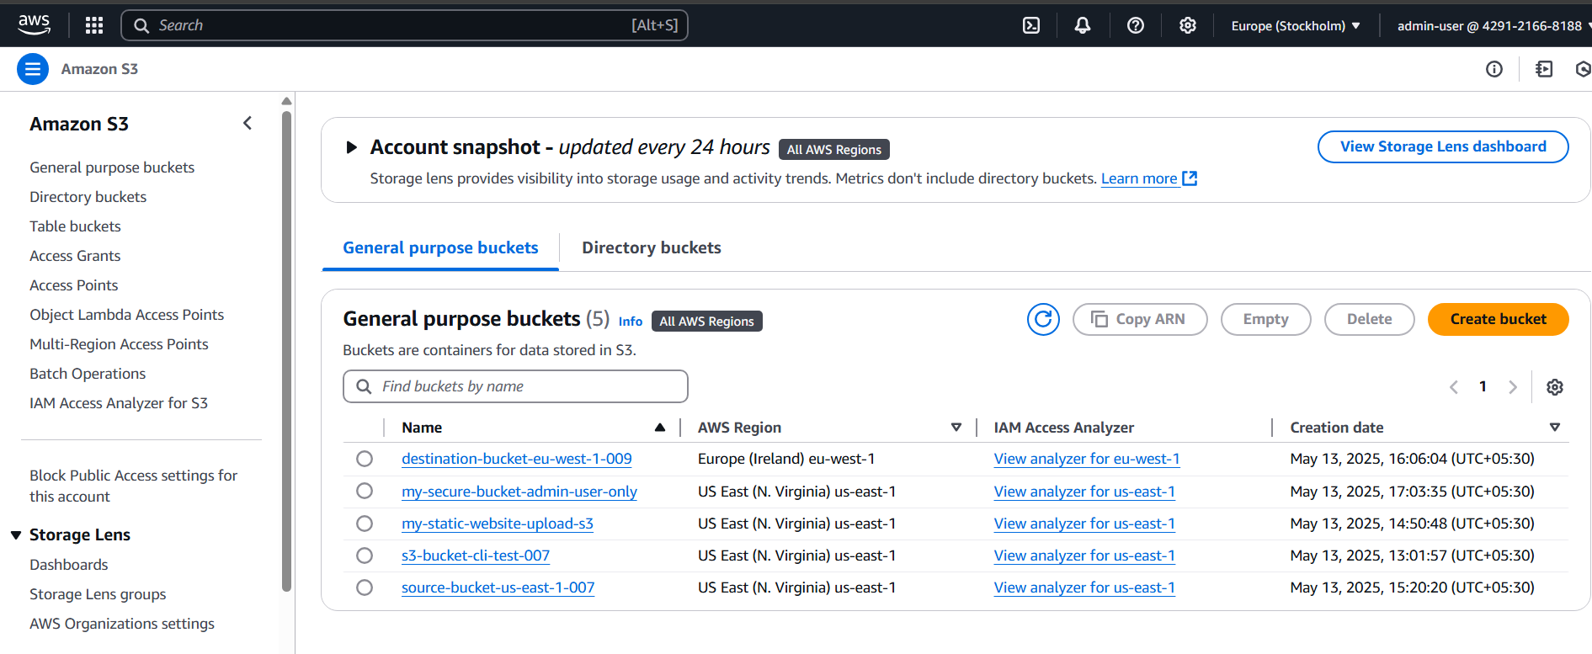

**5) Setup lifecycle policies to automatically transition or delete objects based on specific criteria.**

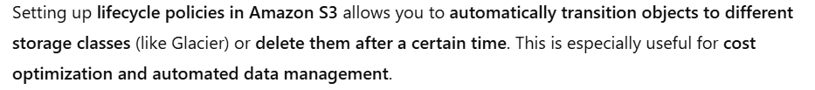

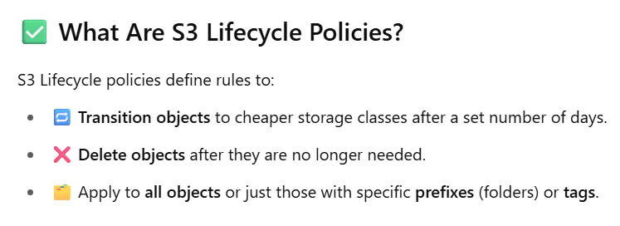

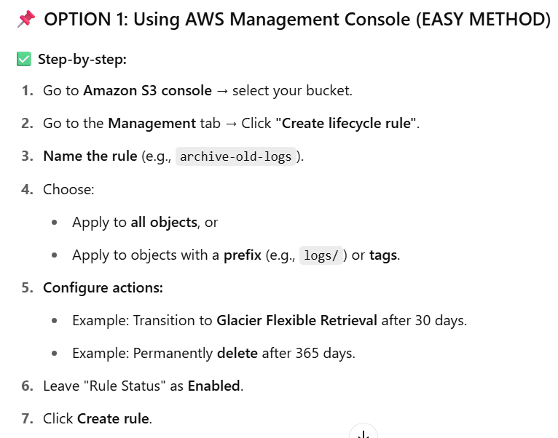

**Note:**

**Explanation of prefix:**

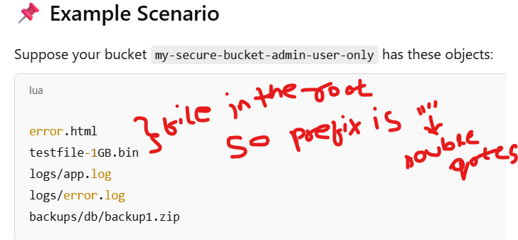

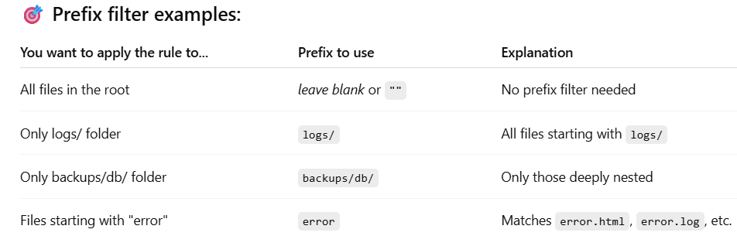

Selecting an existing s3-bucket :

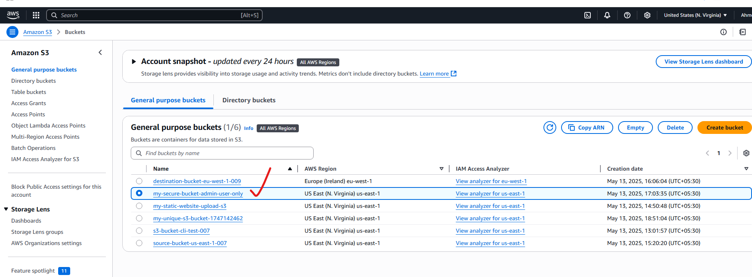

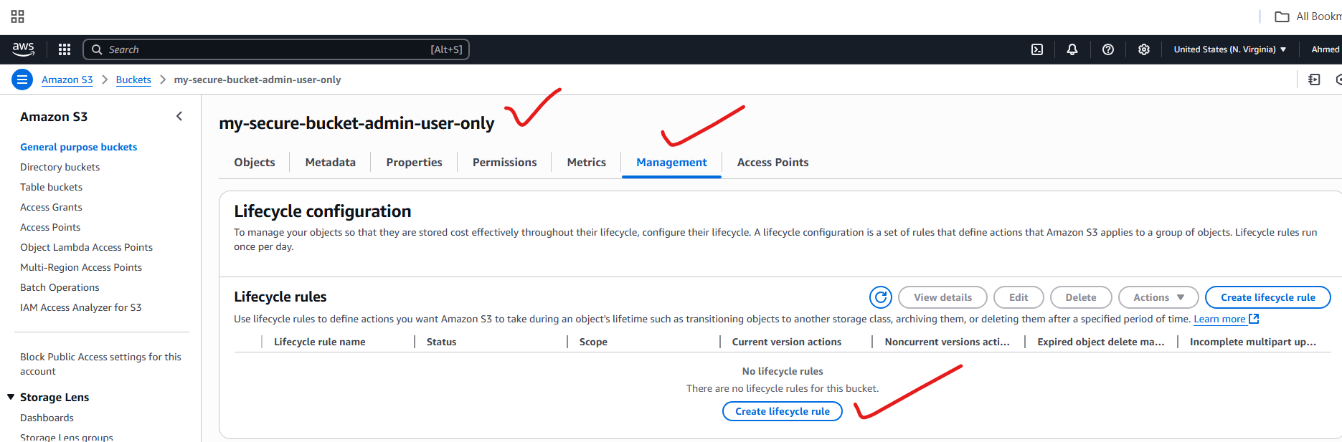

Creating lifecycle rule:

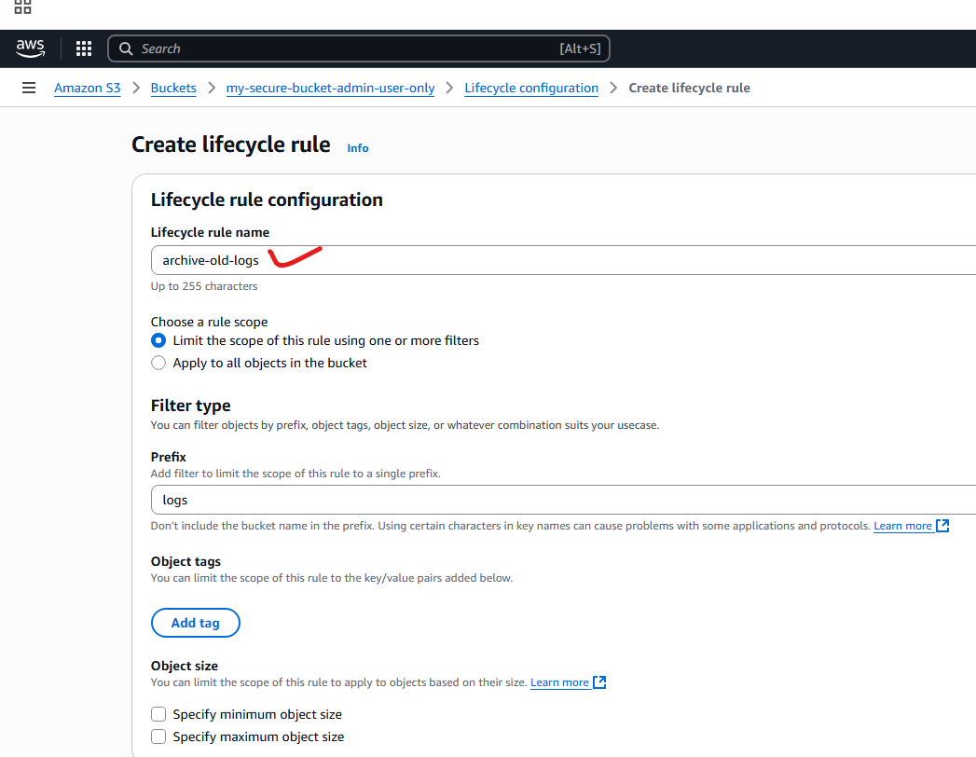

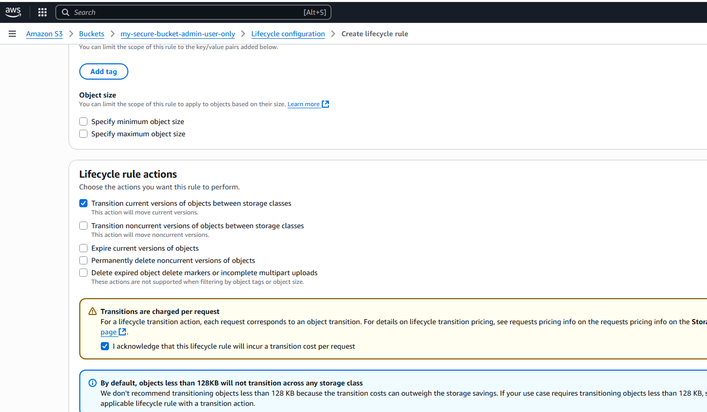

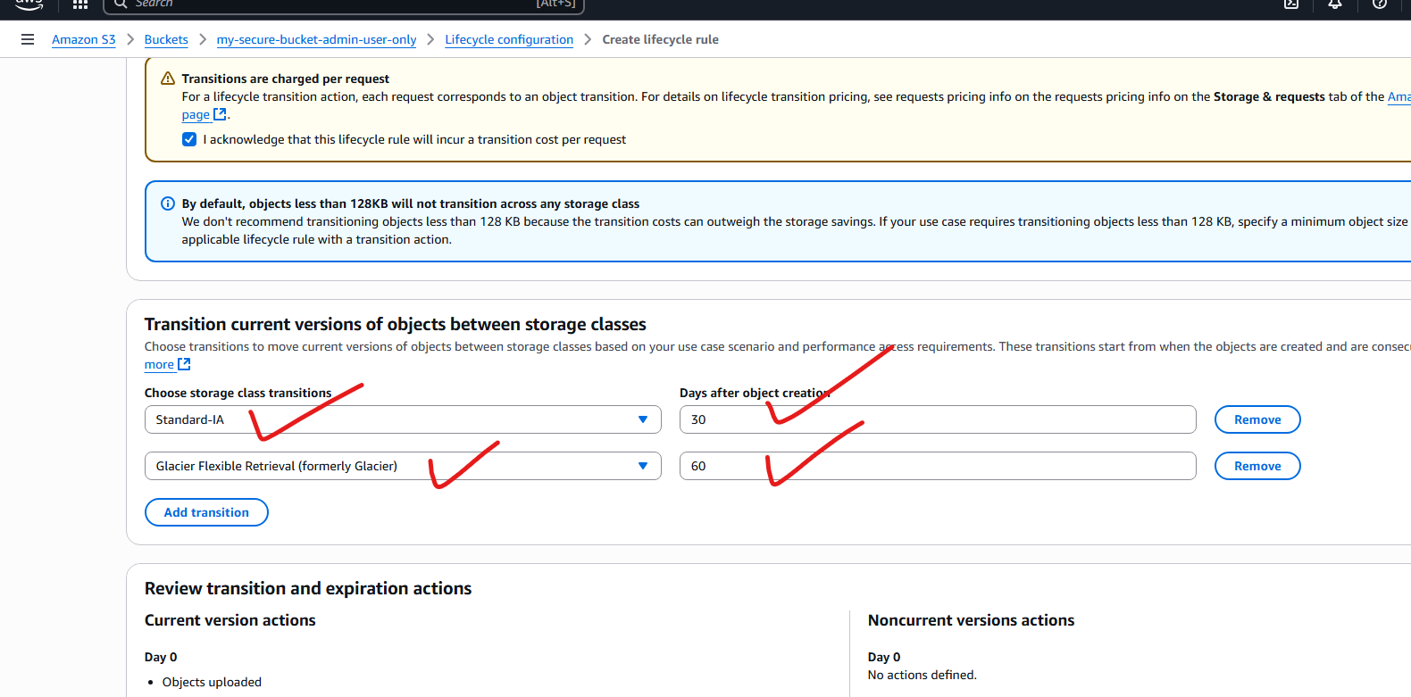

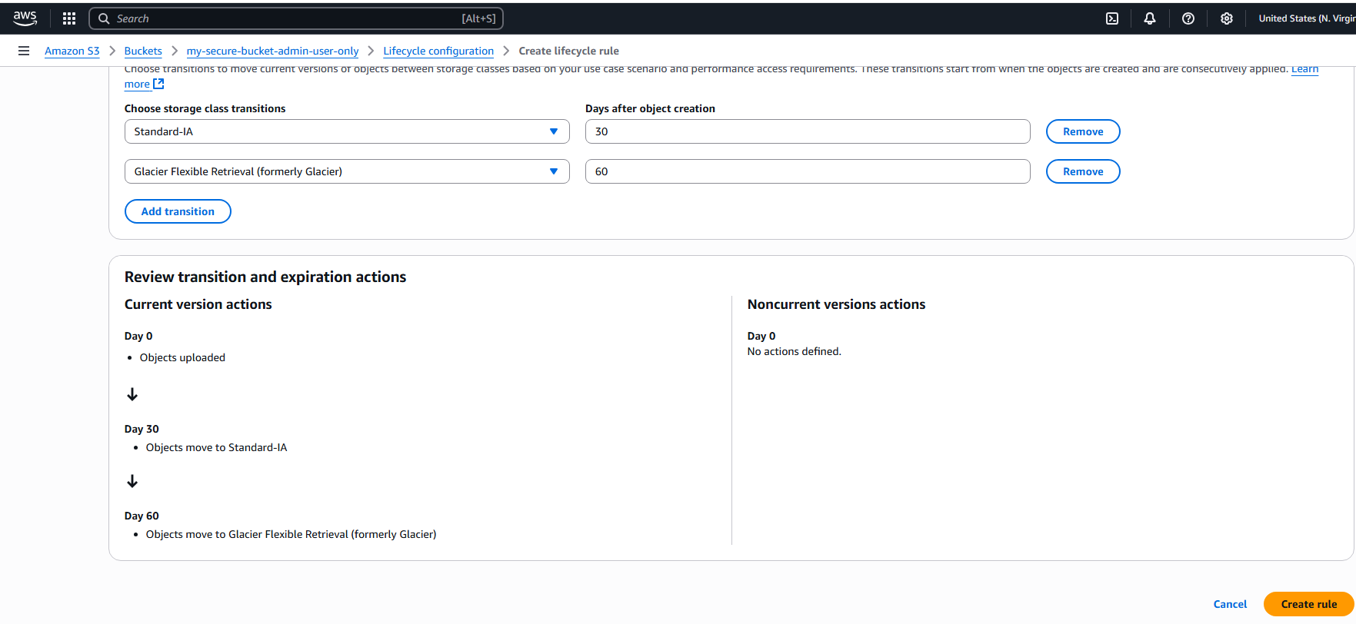

**Successfully applied lifecycle rules:**

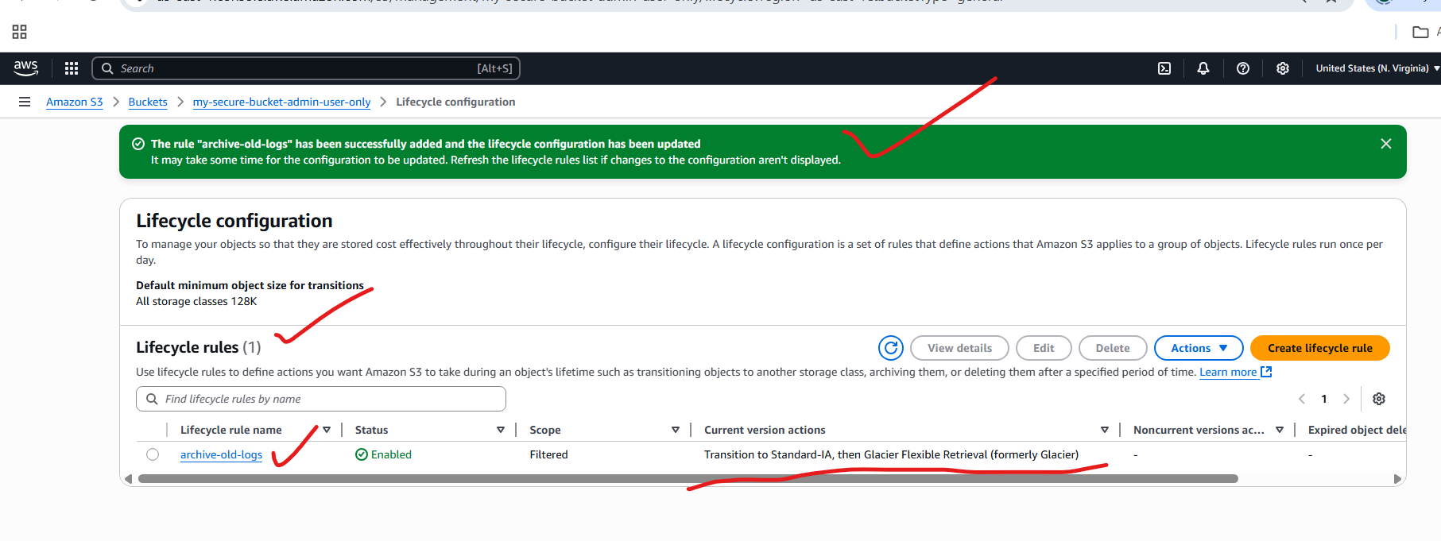

**6) Push some objects in s3 using AWS CLI**

**Creating an s3 bucket:**











**S3 bucket is created:**



**Now I want to move the objects from CLI to s3 bucket:**

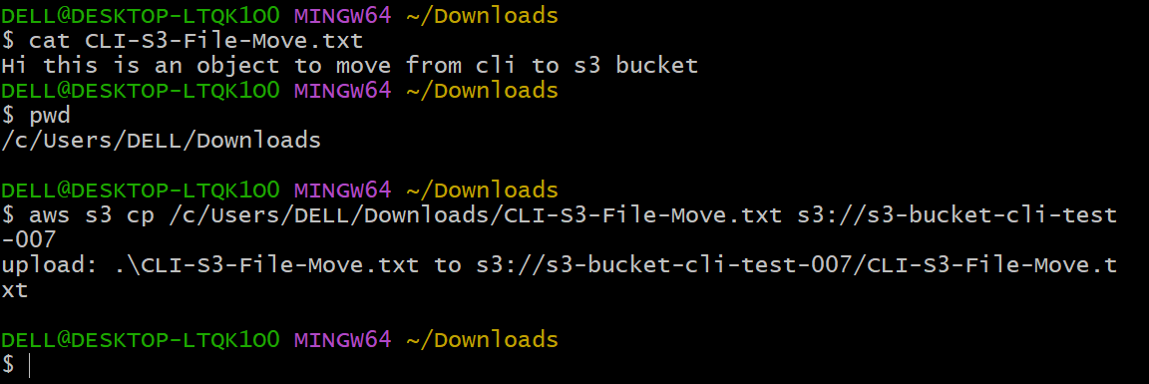

**Object moved from cli to s3 bukcet:**

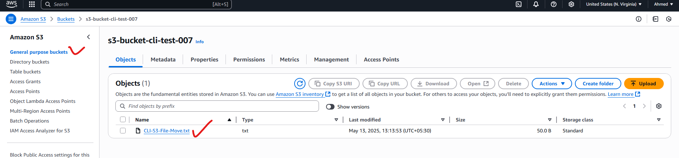

**7) Write a bash script to create s3 bucket.**



**Note:**

**----- If AWS already configured in your terminal (CLI) then directly to for bash script logic,**

**----- if not then first configure the AWS in (CLI)**

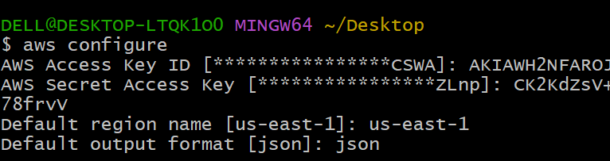

**Logic: create-s3-bucket.sh**

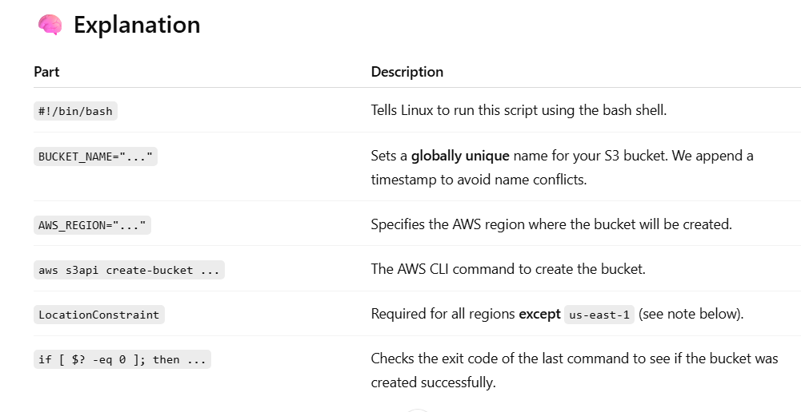

**Iam creating s3 bucket in us-east-1, so I follow the below script:**

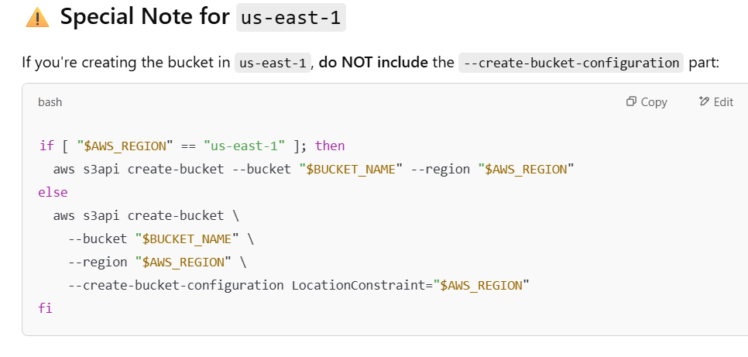

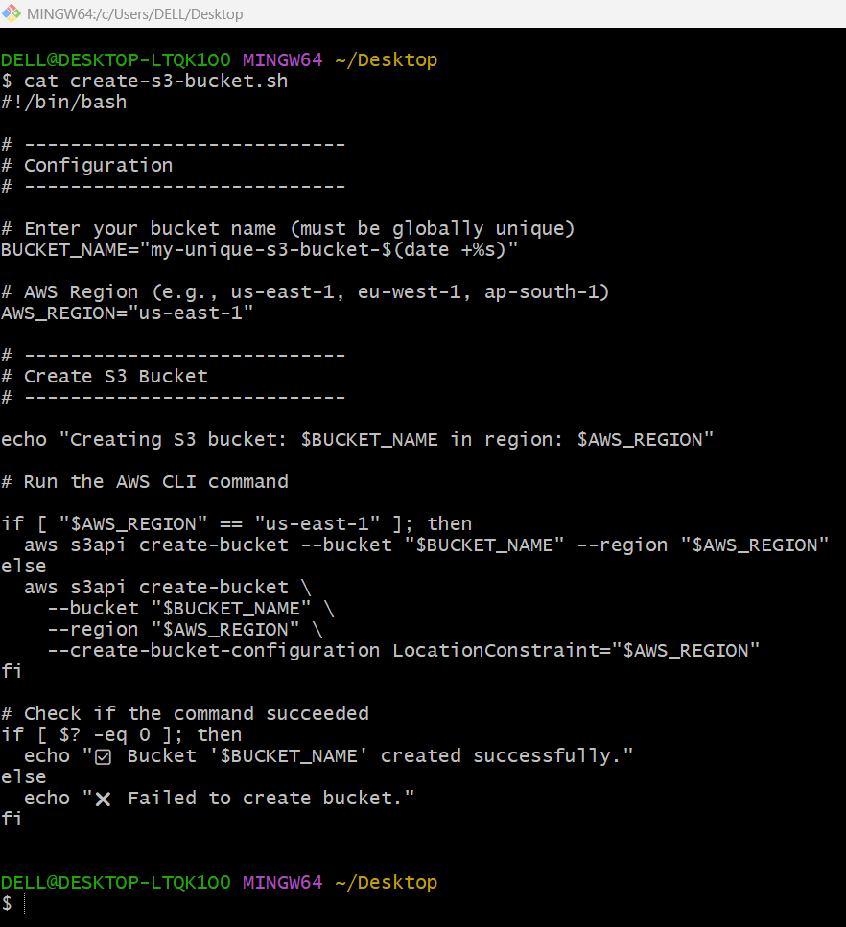

**Make it executable:**

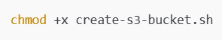

**Run it:**

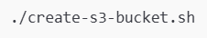

**Successfully created s3-bucket by using CLI:**

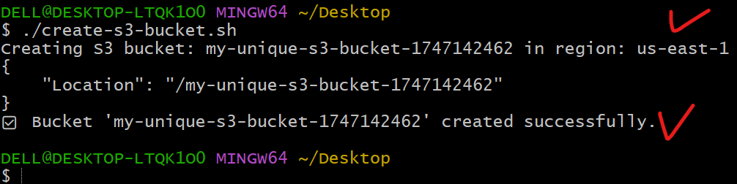

**Successfully created s3-bucket from cli:**

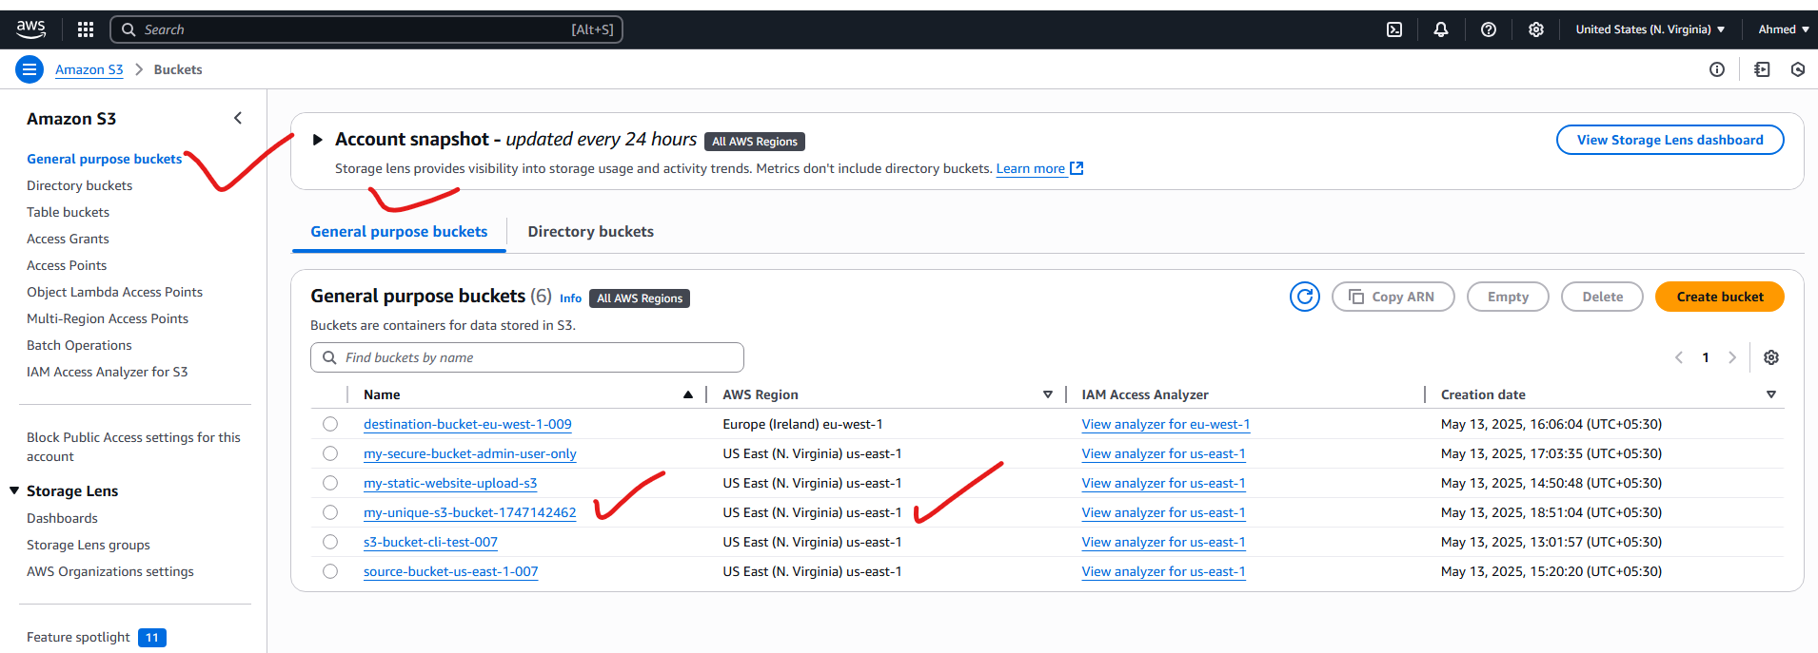

**8) Upload one 1 gb of file to s3 using cli**

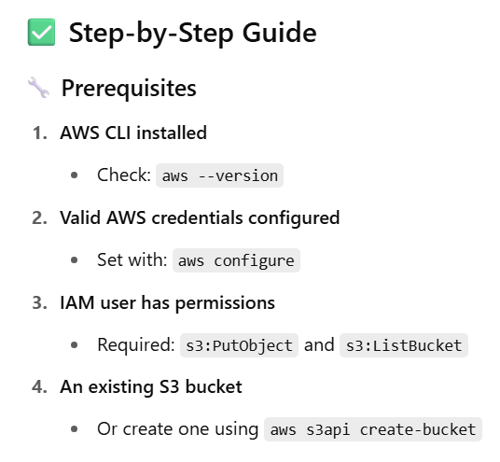

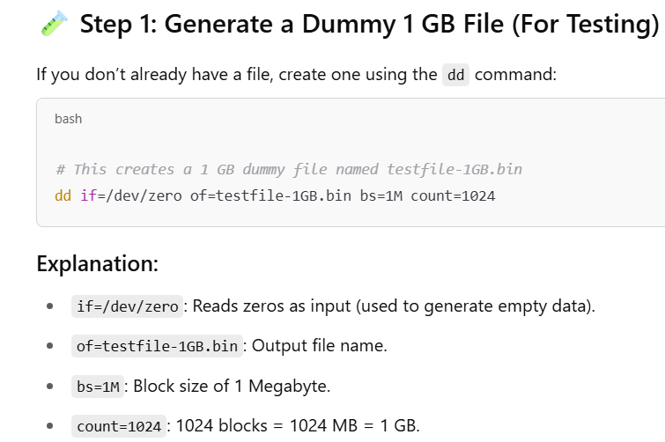

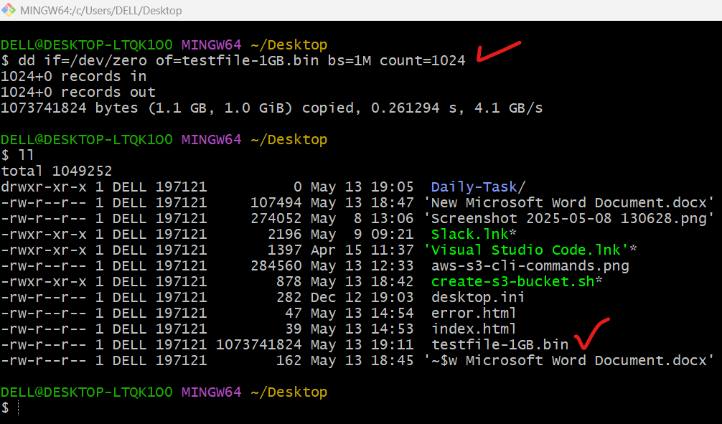

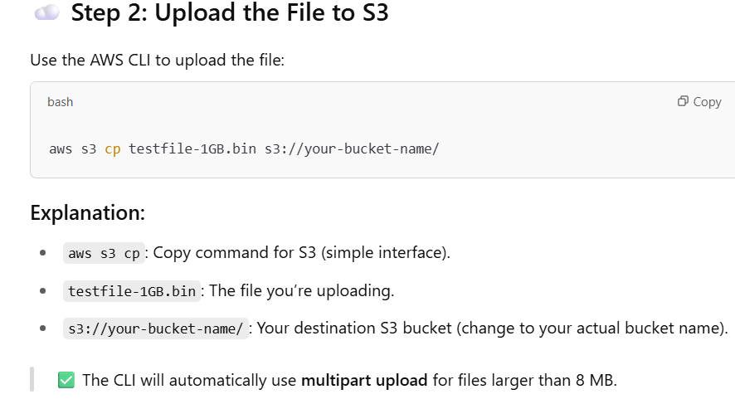



**Successfully moved 1gb file to s3 bucket using CLI:**

